Sediment Standards Project Survey:

What We Heard



September 2025

## **Executive Summary**

**Purpose**

A partnership undertaken between the British Columbia (BC) Ministry of Environment and Parks (the Ministry) and the Science Advisory Board for Contaminated Sites (SABCS) has launched the first phase of a multi‑year effort to modernize Contaminated Sites Regulation (CSR) sediment standards. The initiative will develop a transparent, risk‑based scientific framework that incorporates bioavailability, contaminant mixtures, and cumulative‑effects endpoints to ensure holistic protection of aquatic ecosystems, including the wildlife and people who depend on them.

In April 2025, the SABCS initiated the Sediment Standards Project to develop a scoping plan for reviewing and updating the CSR sediment standards. The SABCS established the Science and Standards Technical Advisory Committee (SSTAC) to oversee and directly support the Sediment Standards Project, including a multi-faceted public engagement process. On May 30, 2025, the public survey was started to gather feedback on the effectiveness and practicality of the current CSR Schedule 3.4 sediment standards from those who work with them most closely. The feedback from the public survey will be used to inform the next phase of public engagement, which is a half-day session at the Canadian Ecotoxicity Workshop in Victoria on October 27, 2025.

**Engagement Method**

An online survey was distributed to SSTAC members and other qualified environmental professionals between May 30 and July 31, 2025. This report summarizes the feedback received from respondents (43 complete and 18 additional partial responses), representing a cross-section of expert opinion from environmental consultants, industry representatives, academics, non-government organizations, and government regulators.

**Key Themes**

The feedback received was detailed and consistent, coalescing around several critical themes:

* **Widespread Dissatisfaction with the Status Quo:** A strong consensus emerged that the current standards are outdated and not sufficiently protective of the environment. A striking 73% of respondents rate the standards as "Not Effective" or "Slightly Effective" at preventing harmful bioaccumulation. A significant concern is their failure to address this pathway, which can lead to contaminants moving up the food chain and posing a risk to wildlife and human health.
* **Practical Challenges in Application:** Respondents highlighted significant difficulties in applying the current standards. Common issues include a limited list of regulated contaminants that omits substances of emerging concern, ambiguity in the classification of "typical" versus "sensitive" sediments, and the standards' failure to account for the bioavailability of contaminants in different environmental settings.
* **The Call for a Broader, More Protective Scope:** Respondents overwhelmingly advocate for a framework that is more comprehensive and protective. This is most evident in the demand to expand the list of regulated contaminants, which 95% of respondents rated as "Essential" or "Very Important." Furthermore, the need to address bioaccumulation was a critical concern, with 68% viewing a "Dual Standard" approach as "Very Necessary" or "Essential."
* **A Mandate for a More Sophisticated, Science-Based Approach:** There is a strong desire to move beyond simple, conservative "bright-line" standards towards a more nuanced, evidence-based system. This is supported by the 91% of respondents who see incorporating bioavailability adjustments as "Essential" or "Very Important," and the 86% who believe a formal, tiered assessment framework would be beneficial.
* **Strong Support for Clear Guidance and Education:** Participants emphasized that new standards, particularly if more complex, must be accompanied by clear, comprehensive guidance documents, standardized methodologies, and accessible training programs to ensure consistent and effective implementation by regulators and practitioners.

**Conclusion**

The feedback gathered provides a clear mandate and a well-defined direction for updating the BC CSR sediment standards. This input will be instrumental in developing a modernized framework that is more protective of the environment and human health, and more practical for regulators and practitioners to implement across BC's diverse aquatic ecosystems.

Executive Summary 1

1. Introduction 4

1.1 Background 4

1.2 Purpose of Engagement 4

1.3 Methodology 4

1.4 About This Report 5

2. Overview of Respondents 5

Professional Involvement 5

Familiarity with Current Standards 6

3. Summary of Feedback: Key Themes 7

3.1 Theme A: Effectiveness of Current Standards 7

3.2 Theme B: Practicality and Challenges of Application 10

Issues with Specific Parameters and Contaminants 11

Methodological and Interpretive Challenges 11

3.3 Theme C: The Need for New and Revised Standards 12

Key Suggestions for New Standards 13

3.4 Theme D: Data, Guidance, and Implementation 14

Data Gaps 15

Guidance and Training 15

3.5 Theme E: Noteworthy Insights 16

4. Respondents' Preferred Actions & Approaches 16

5. Summing It Up 18

Are we on the right track? 18

**6. Appendices 20**

Appendix A: Survey Questions 20

Appendix B: Survey Methods and Constraints 22

Appendix C: Survey Responses 23

Section 2: Proposed Approaches for Updating BC CSR Sediment Standards 23

Part 1: Background 23

Part 2: About You 26

Section 3: Current BC CSR Sediment Standards (Schedule 3.4) 26

Section 4: Proposed Approaches for Updating Standards 45

Section 5: Methodological Preferences & Data Needs 63

## **1. Introduction**

### **1.1 Background**

BC’s diverse aquatic ecosystems, from its rugged coastline and intricate fjords to its thousands of freshwater rivers and lakes, are invaluable ecological, cultural, and economic resources. Sediments form the foundation of these aquatic environments, providing critical habitat for a wide range of organisms. However, sediments can also act as a sink for contaminants, accumulating pollutants over time. These contaminants can then be released back into the water or enter the food web, posing risks to aquatic life and human health.

To manage these risks, the province established sediment standards under the CSR. These standards are intended to be used in the assessment and remediation of contaminated sites to ensure the protection of both environmental and human health. The current sediment standards, found in Schedule 3.4 of the CSR, have been in place since 2003. In that time, scientific understanding of sediment toxicology, contaminant fate and transport, and human and ecological risk assessment has advanced significantly.

### **1.2 Purpose of Engagement**

Recognizing the need to ensure the provincial regulatory framework reflects current science, the SABCS is undertaking a comprehensive review of the CSR sediment standards. A key component of this review is engagement with the professionals who apply these standards in their daily work.

The primary objective of this engagement was to gather expert feedback from environmental consultants, industry representatives, government regulators, academics, non-government organizations and other qualified professionals. The survey sought to understand their perspectives on the effectiveness and practicality of the existing sediment standards and to solicit recommendations for improvement.

### **1.3 Methodology**

An online survey was conducted for two months between May 30 and July 31, 2025. The survey was posted online and distributed to members of the SSTAC to reach and other professionals identified as having expertise in the field of contaminated sites and sediment quality assessment. The survey was advertised using a variety of channels including the Ministry’s [Site Remediation News service](https://www2.gov.bc.ca/gov/content/environment/air-land-water/site-remediation/site-remediation-news), the SABCS website, LinkedIn posts and direct email to contacts who may not be included in the channels used for advertising the survey.

A total of 61 partial and 43 complete responses were received and analyzed. The analysis involved quantitative summaries of multiple-choice questions and a qualitative thematic analysis of open-ended responses to identify key issues, common challenges, and preferred approaches for modernizing the sediment standards.

### **1.4 About This Report**

This "What We Heard" report presents a neutral summary of the feedback received during the engagement period. The views and opinions expressed are those of the survey respondents and do not necessarily represent the position of the SABCS or the Government of BC.

The report is organized into key themes that emerged from the survey data. Direct, anonymized quotes are used throughout to illustrate the perspectives shared by participants. Results from this report will directly inform the project's next phases.

## **2. Overview of Respondents**

The survey successfully reached a targeted audience of highly experienced professionals who work directly with the BC CSR sediment standards. The quality and depth of the responses reflect a strong collective expertise in contaminated sites management, environmental science, and regulatory compliance.

#### **Professional Involvement**

The vast majority of respondents are actively engaged in work that involves assessing or managing sediment quality. This direct, hands-on experience provides a valuable, practice-based perspective on the strengths and weaknesses of the current regulatory framework. As shown in Figure 1, 64% of respondents indicated that their professional work involves assessing or managing sediment quality, with an additional 21% reporting they sometimes engage in this work.

**Figure 1: Does your professional work involve assessing or managing sediment quality? (n=61)**

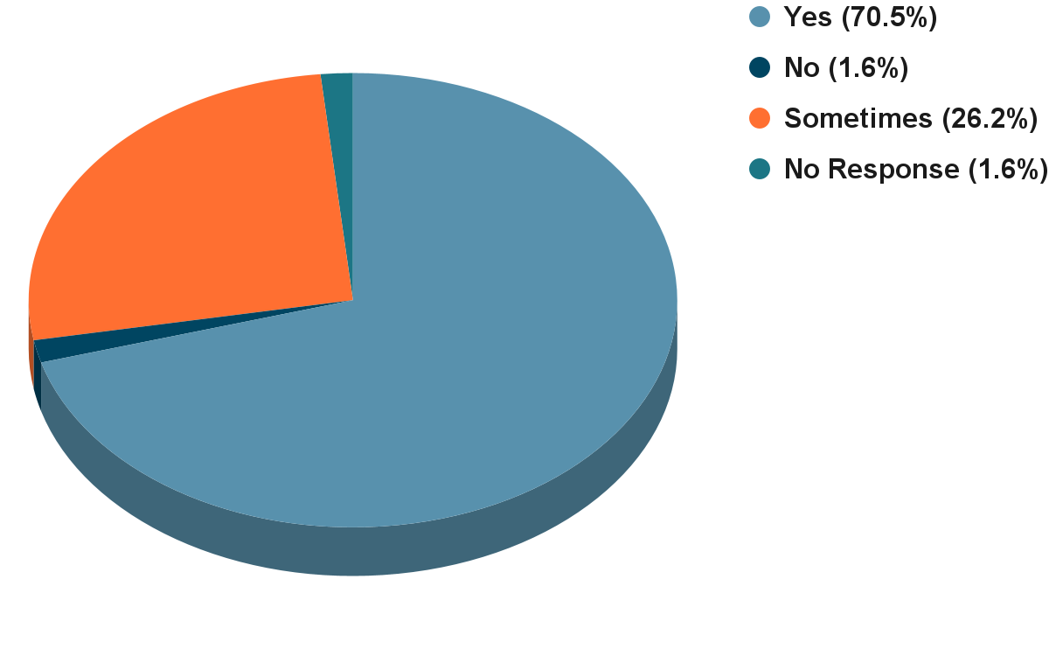

#### **Familiarity with Current Standards**

The feedback received is from a well-informed audience. Over 70% of respondents described themselves as "Very Familiar" or "Familiar" with the current BC CSR Schedule 3.4 numerical sediment standards. This high level of familiarity ensures that the critiques and suggestions provided are not based on speculation, but on years of practical application.

**Figure 2: How familiar are you with the current BC CSR Schedule 3.4 numerical sediment standards? (n = 61)**

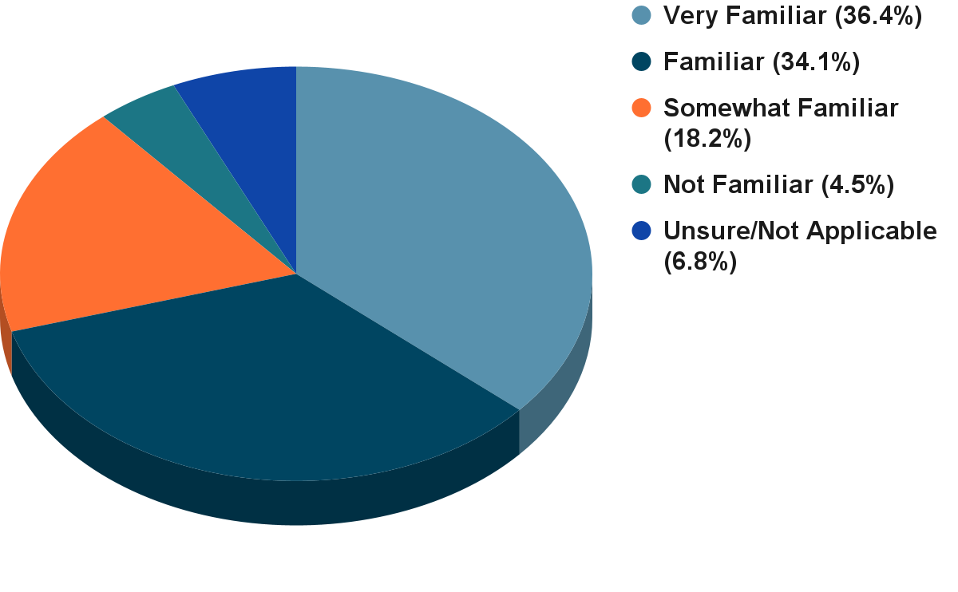

The professional background of respondents was diverse, including environmental consultants, representatives from industry, academics, non-government organizations and regulators from various levels of government. This mix of perspectives provides a balanced and comprehensive overview of how the standards are used and perceived across different sectors. The strong consensus on key issues that emerges from this diverse group underscores the validity of their shared concerns and recommendations.

## **3. Summary of Feedback: Key Themes**

### **3.1 Theme A: Effectiveness of Current Standards**

A predominant theme throughout the survey responses is that the current sediment standards are outdated and not sufficiently protective of the complex aquatic ecosystems in BC. While some respondents see value in the standards as a basic screening tool, the majority believe they fail to address key risk pathways, particularly the bioaccumulation of contaminants.

**Figure 3: Perceived Effectiveness for Protecting Benthic Organisms (n = 59)**

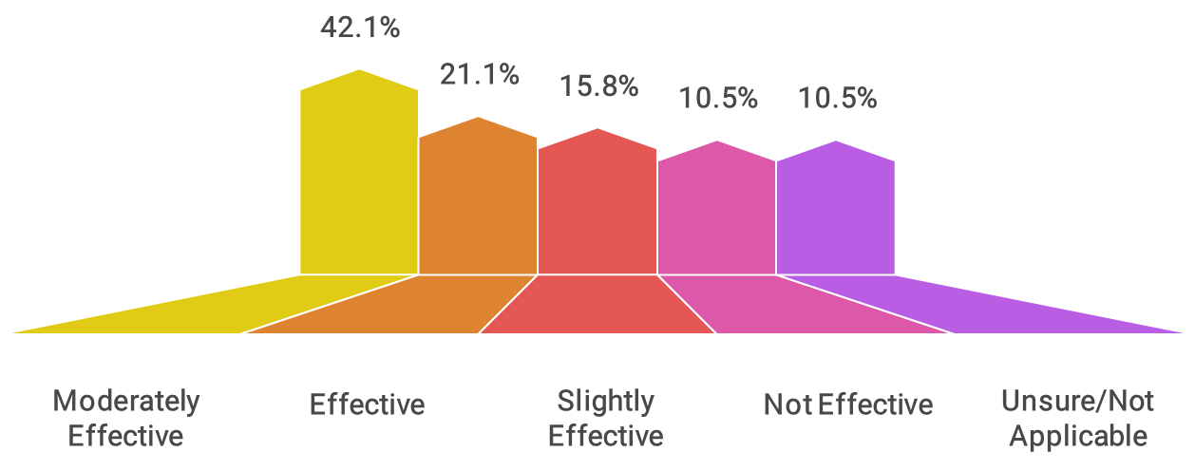

**Figure 4: Perceived Effectiveness for Preventing Harmful Bioaccumulation (n = 59)**

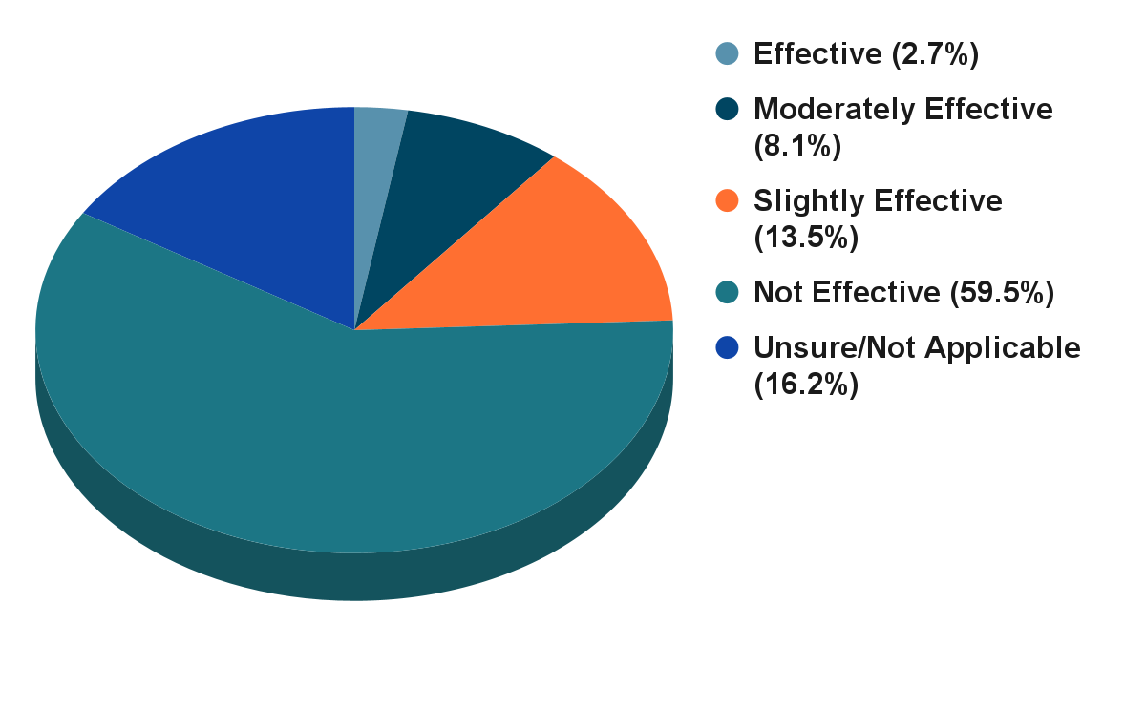

As illustrated in Figures 3 and 4, there is a stark contrast in how respondents view the standards' ability to protect different parts of the ecosystem. While over 60% of respondents believe the standards are at least "moderately effective" at protecting benthic organisms, this confidence plummets when considering the broader food web. A striking 73% stated the standards are "Not Effective" or "Slightly Effective" at preventing harmful bioaccumulation. This points to a critical gap: the standards are perceived as focusing on direct toxicity to sediment-dwelling organisms while largely ignoring the transfer of contaminants up the food chain to fish, marine mammals, and ultimately humans.

This concern was frequently articulated in the written comments, where participants highlighted the limitations of a framework that does not explicitly account for bioaccumulation risks.

*"The BC CSR sediment standards are not appropriate or adequate to protect upper trophic level organisms, apex predators and humans at the top of foodwebs, as these sediment standards were or are designed for the protection of low tropic level species and benthic organisms."* - Survey Respondent 6

*"No bioaccumulation protection is also a scary consideration, resulting in the need to clean up to levels below standards but having a challenging time making a convincing argument."* - Survey Respondent

This lack of bioaccumulation standards was cited as a direct cause of under-protection. One respondent noted an experience where contaminant levels were below the numerical standards, yet tissue sampling revealed that contaminants were accumulating in organisms at levels above critical thresholds. Another pointed out that the standards are not protective enough for Indigenous communities that rely on traditional seafood harvesting, where bioaccumulation poses a direct human health risk.

Conversely, several respondents argued that in certain situations, the standards are *over-protective*. This occurs most often in areas with naturally high background concentrations of metals, where the generic, province-wide standards are lower than what is found in undisturbed local sediment.

*"I know that there have been instances where arsenic and copper concentrations in the Fraser River are naturally higher than the standards, so this would be an example of overprotectiveness."* - Survey Respondent

This "one-size-fits-all" approach can lead to unnecessary and costly investigations or remediation efforts at sites where the elevated concentrations are natural and pose no additional risk to the environment or human health.

### **3.2 Theme B: Practicality and Challenges of Application**

While the current standards are seen as relatively simple to apply—comparing a lab result to a number in a table—respondents identified significant practical challenges that undermine their utility and scientific defensibility.

**Figure 5: Practicality of Applying Current Standards (n = 60)**

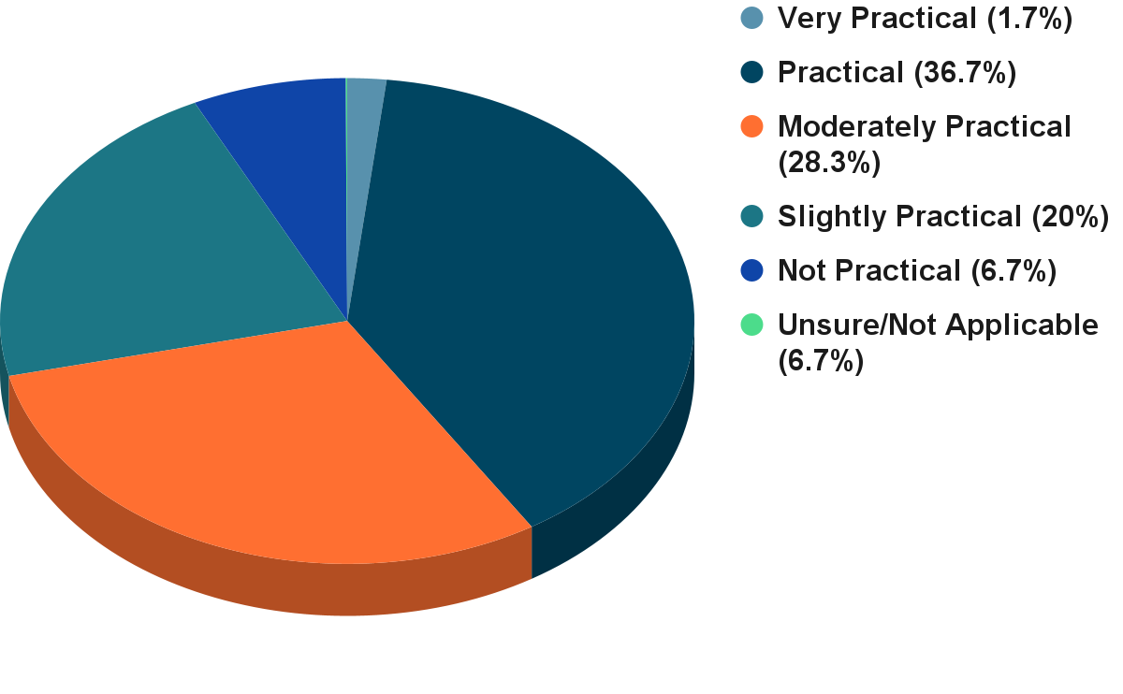

The feedback indicates that the perceived practicality of the standards is largely due to their simplicity, but this simplicity comes at a cost. The most significant challenges identified by respondents relate to the limited scope of the standards, ambiguity in their application, and a lack of scientific transparency.

#### **Issues with Specific Parameters and Contaminants**

A major and recurring criticism is that the list of regulated contaminants in Schedule 3.4 is insufficient and outdated.6 Professionals frequently encounter substances for which no provincial standard exists, forcing them to rely on guidelines from other jurisdictions or conduct costly, site-specific risk assessments.

*"The CSR list of sediment standards is surprisingly short."* - Survey Respondent

*"There are numerous COCs [contaminants of concern] that are not within Schedule 3.4 including TBT. Additionally, there are no human health considerations for sediments."* - Survey Respondent

Respondents specifically highlighted the need for standards for emerging contaminants like per- and polyfluoroalkyl substances (PFAS), current-use pesticides, organotins (e.g., tributyltin), microplastics, and petroleum hydrocarbons (PHCs). The lack of PHC standards was noted as a particular deficiency, with one respondent describing the existing federal models as "too low (not realistic)" for BC conditions.

#### **Methodological and Interpretive Challenges**

Beyond the contaminant list, respondents expressed frustration with the methodology and interpretation of the existing standards.

* **Typical vs. Sensitive Sediments:** The distinction between "typical" and "sensitive" sediments was a common point of contention. The definition of a "sensitive" sediment is seen as overly broad and restrictive, resulting in its default application to nearly all sites, including industrial harbours and marinas. This negates the purpose of having a two-tiered system and can lead to the application of overly stringent standards that may not be achievable or necessary.

*"The typical vs sensitive approach is a bit clunky. At the very least, the terms don't seem appropriate. Benthic organisms in Industrial harbours may still be sensitive even if there's a lower protection goal allowed for those environs."* - Survey Respondent

* **Bioavailability:** A fundamental scientific criticism is that the standards are based on total contaminant concentrations and do not account for bioavailability—the portion of a chemical that is actually available to be taken up by organisms. This can lead to a mischaracterization of risk.

*"The bioavailability in sediment helps us understand not just how much contaminant is present, but whether it is causing harm or influencing environmental processes. This distinction is required to make informed decisions in managing contaminated sites."* - Survey Respondent

* **Lack of Transparency:** Many professionals noted that the scientific basis and derivation documents for the current standards are not readily available. This makes it difficult to understand the level of protection the standards are intended to provide and to justify site-specific modifications when appropriate.

### **3.3 Theme C: The Need for New and Revised Standards**

Given the perceived shortcomings of the current regulations, there is overwhelming support among survey respondents for a comprehensive update. This support is not merely for adjusting existing values but for developing a fundamentally new, more scientifically robust framework for assessing sediment quality.

**Figure 6: How necessary is the proposed 'Dual Standard' approach? (n = 60)**

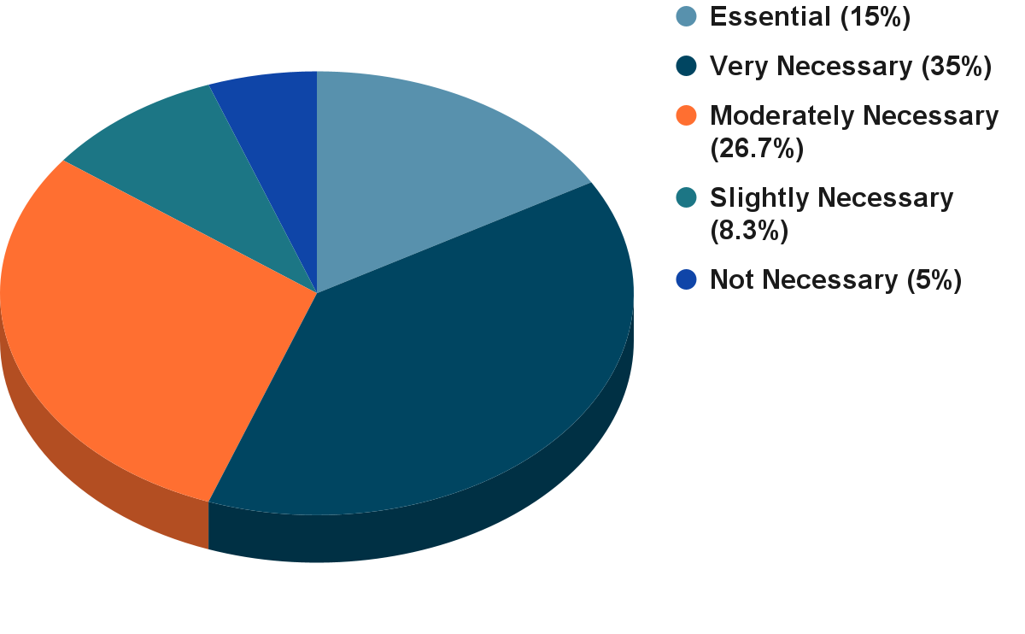

**Figure 7: How important would a formal, bioavailability adjustment option within the tiered framework be? (n = 59)**

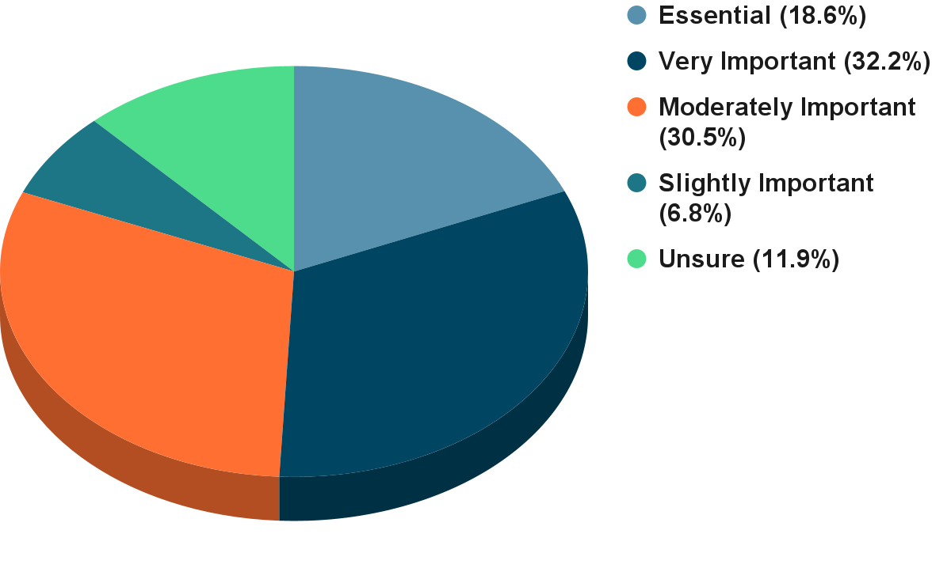

**Figure 8: How beneficial would a formal, tiered framework be? (n = 59)**

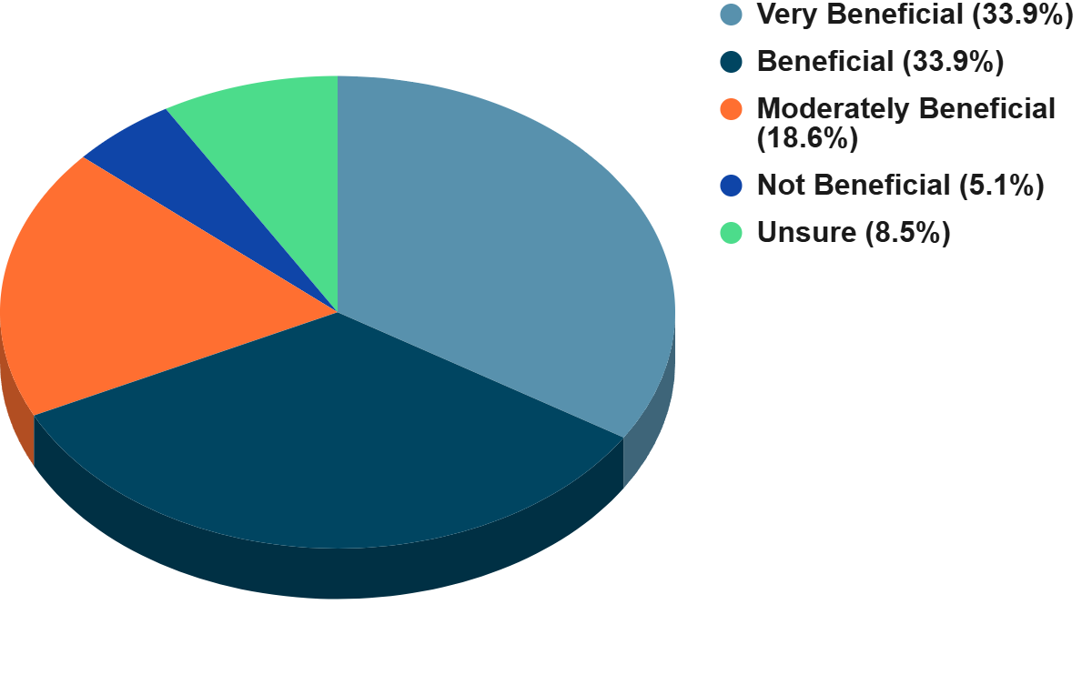

The desire for a modernized framework is clear, with a strong mandate coupled with clear preferences for the *form* these new standards should take.

#### **Key Suggestions for New Standards**

Respondents provided specific, constructive suggestions for developing a more effective and scientifically defensible sediment standards framework.

* **Dual-Standard Approach:** There is strong support for developing separate standards for the protection of benthic organisms (direct toxicity) and for the protection against bioaccumulation (food web effects). This "dual standard" approach is seen as a critical step to address the primary weakness of the current regulations. As one respondent noted, this approach would  
  *"address more receptors (i.e., not just focus on benthic invertebrates)"* and provide a more holistic assessment of risk.
* **Incorporate Bioavailability:** A clear majority of respondents (over 88%) believe it is "Essential" or "Very Important" to systematically incorporate bioavailability adjustments into the standards, using metrics such as Total Organic Carbon (TOC) and Acid Volatile Sulfides/Simultaneously Extracted Metals (AVS/SEM). This would allow for a more accurate assessment of risk by considering the fraction of a contaminant that is actually available to cause harm, rather than relying solely on total concentration.
* **Tiered, Risk-Based Framework:** There is broad agreement (over 86% see it as "Beneficial" or "Very Beneficial") that a formal, tiered assessment framework would improve sediment management in BC. Such a framework would allow for simple screening at Tier 1 using conservative numerical standards, with options for more complex, site-specific investigations at higher tiers. This could include tools like:
  + Food Web Models (FWMs) to simulate contaminant transfer through the food chain.
  + Biota-Sediment Accumulation Factors (BSAFs) to quantify the relationship between contaminant levels in sediment and in organisms.
  + Toxicity Testing to directly measure the effects of contaminated sediment on aquatic life.

*"I believe this [a tiered framework] can be extremely beneficial, especially when combined with a tiered assessment framework."* - Survey Respondent

This approach would provide the flexibility needed to manage the wide variety of sites and conditions found across the province, from remote, pristine environments to complex, industrialized harbours.

### **3.4 Theme D: Data, Guidance, and Implementation**

While there is strong enthusiasm for new, scientifically advanced standards, respondents were equally clear that new rules alone are not enough. The success of a modernized framework depends on robust data, clear guidance, and comprehensive training to support its implementation.

#### **Data Gaps**

A significant barrier to effective sediment quality assessment is the lack of critical data. Respondents identified several key areas where more information is needed:

* **Emerging Contaminants:** The most frequently cited data gap is the absence of standards for contaminants of emerging concern such as PFAS, current-use pesticides, organotins, microplastics, and PHC.
* **Background Concentrations:** There is a need for provincially or regionally established background concentration data for metals and other substances. This would help distinguish between natural and anthropogenic sources of contamination and prevent the misclassification of sites.
* **Bioaccumulation Factors:** To properly assess bioaccumulation risk, BC-specific data is needed, including Biota-Sediment Accumulation Factors (BSAFs) for local species and information on their dietary habits.
* **Sampling and Analysis:** Respondents also called for better guidance on sampling density and methodologies, and improved laboratory analytical methods and lower detection limits to support advanced assessments.

#### **Guidance and Training**

Respondents universally agreed that any new framework must be accompanied by clear, accessible, and practical guidance. There is a strong desire for transparency in how the new standards are developed and how they are intended to be used.

*"Provide decision trees, flowcharts, and worked examples in guidance documents. Integrate chemistry, toxicity tests, and benthic community data in a weight-of-evidence (WOE) approach."* - Survey Respondent

*"That would be dependent on what the future framework is, but at the bare minimum there needs to be a presentation on what was done and how the standards were derived."* - Survey Respondent

Specific requests included webinars, detailed technical documents, and training sessions for both regulators and consultants to ensure the new framework is applied consistently and correctly across the province. This emphasis on implementation support highlights a key lesson from past experience: without proper guidance, even the most scientifically sound regulations can be difficult to apply in practice.

### **3.5 Theme E: Noteworthy Insights**

Beyond the major themes, respondents provided several specific and forward-thinking suggestions that warrant consideration in the standards review process:

* **Human Health Dermal Exposure:** One respondent highlighted a potential gap in human health risk assessment, noting that the rate at which contaminants adhere to skin can be significantly higher in wet, intertidal sediments compared to standard terrestrial soils. This could lead to an underestimation of risk for people using these areas for recreation or harvesting.
* **Future-Proofing for Climate Change:** A novel suggestion was to consider incorporating a temperature factor into the standards. The respondent noted that warmer water temperatures, a consequence of climate change, can increase both the toxicity of certain contaminants and the susceptibility of organisms to them.
* **A "One Health" Approach:** One expert advocated for framing the project through a "One Health" lens, which recognizes the interconnectedness of environmental, wildlife, and human health. This approach would align the updated standards with broader goals of ecological and community well-being.

## **4. Respondents' Preferred Actions & Approaches**

The survey responses provide a clear roadmap for modernizing BC's sediment standards. The feedback moves beyond identifying problems to proposing a suite of preferred actions and approaches. The central theme is a shift from a simple, prescriptive system to a more sophisticated, flexible, and scientifically robust framework that better reflects the complexities of aquatic ecosystems.

Based on an analysis of the survey data, the most frequently recommended actions and approaches are summarized in Figure 8.

**Figure 9: Respondents' Most Recommended Approaches (n = 60, 59, 59, 60)**

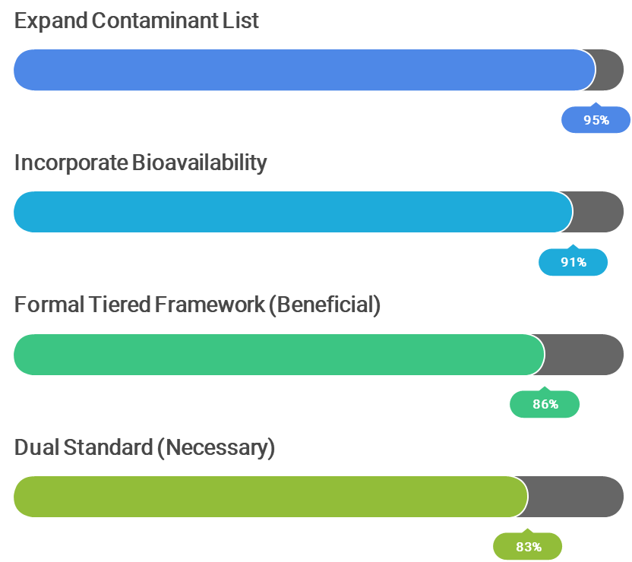

* **Develop Bioaccumulation-Based Standards:** This was the most prominent recommendation. Experts strongly advocate for a "dual standard" approach, with one set of values to protect benthic organisms and another to protect higher trophic levels (including wildlife and humans) from the effects of bioaccumulation. This addresses the most significant perceived weakness of current regulations.
* **Incorporate Bioavailability Adjustments:** There is a strong consensus that standards should not be based solely on total contaminant concentrations. Respondents want a system that accounts for site-specific factors like organic carbon content and AVS, which control how much of a contaminant is actually available to cause harm.
* **Expand List of Regulated Contaminants:** The current list of substances is seen as inadequate. Respondents urged the development of standards for a wider range of chemicals, including emerging contaminants like PFAS, modern pesticides, and PHCs.
* **Establish a Tiered, Weight-of-Evidence Framework:** Professionals support a move towards a more flexible assessment framework. This would allow for simple screening at low-risk sites, while providing clear pathways for more detailed, multi-faceted investigations (e.g., combining chemical analysis with toxicity testing and biological community surveys) at more complex sites.
* **Provide Clear Implementation Guidance:** The call for clear, comprehensive, and practical guidance was universal. This includes the need for transparent documentation on how standards are derived, and decision trees, case studies, and training to ensure consistent application by both industry and regulators.
* **Develop Regional Background Concentrations:** To address the issue of standards being lower than natural levels in some areas, respondents recommended the development of regional background values. This would provide a more realistic baseline for assessing contamination and prevent unnecessary remediation efforts.

## **5. Summing It Up**

The survey engagement process for the Sediment Standards Project has yielded a clear and compelling message from the community of professionals who work with these regulations daily. The feedback demonstrates a strong consensus on the need for change and provides valuable, constructive direction for developing a modernized sediment standards framework for BC.

### **Are we on the right track?**

The overwhelming response from stakeholders confirms that the initiative to review and update the sediment standards is not only welcome but essential. When asked about the necessity of developing new numerical standards, 88% of respondents identified it as either "Essential", "Very Important" or “Moderately Important.” This represents a powerful mandate for reform.

**Figure 10: Is it Important to Develop New Sediment Standards? (n = 43)**

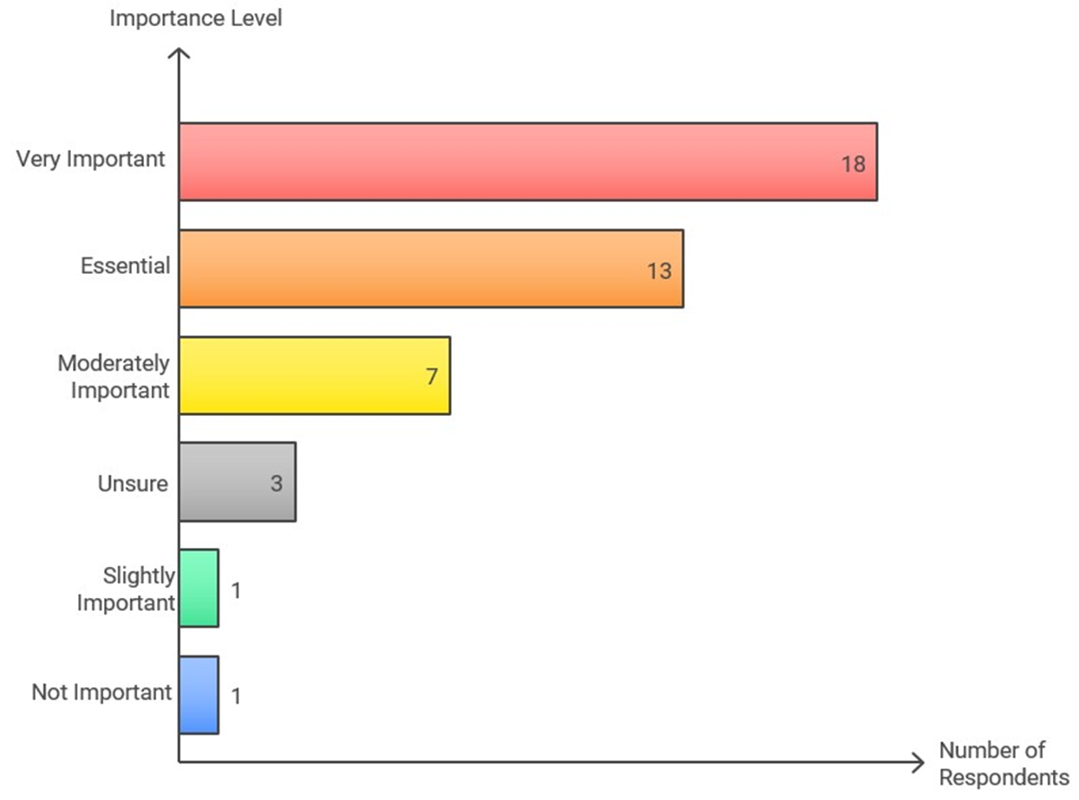

This strong support indicates that the professional community is ready and willing to embrace a new, more scientifically advanced approach to sediment management. The issues raised, from the lack of bioaccumulation standards to the need for clear guidance, are not minor critiques but point to fundamental gaps in the current system that must be addressed.

The input gathered through this survey will be invaluable in guiding the next phase of the Sediment Standards Project. The feedback highlights a clear path forward: developing a robust, tiered framework that includes separate standards for benthic and bioaccumulation protection, incorporates bioavailability, addresses emerging contaminants, and is supported by clear guidance and training. By incorporating this expert feedback, the SABCS and the Ministry can develop sediment standards that are both scientifically defensible and practically applicable, ensuring the long-term health of BC's aquatic environments.

# 6. Appendices

## Appendix A: Survey Questions

1. Does your professional work involve protecting human health or the environment from pollution and/or contamination? (Multiple Choice)
2. Does your professional work involve assessing or managing sediment quality? (Multiple Choice)
3. How familiar are you with the current BC CSR Schedule 3.4 numerical sediment standards? (Rating-scale)
4. In your experience, how effective are the current BC CSR sediment standards at protecting benthic organisms (e.g., worms, clams, insects living in sediment)? (Rating-scale)
5. In your experience, how effective are the current BC CSR sediment standards at preventing harmful bioaccumulation of contaminants in the aquatic food web (e.g., accumulation in fish, wildlife)? (Rating-scale)
6. How practical are the current BC CSR sediment standards to apply in site assessments and management? (Rating-scale)
7. Which aspect of the current BC CSR sediment standards presents the biggest challenge in your work? (Multiple Choice)
8. Please elaborate on the biggest challenge you identified in the previous question, or describe any other significant challenges you face when applying the current BC CSR sediment standards. (Open-ended)
9. Can you provide examples from your experience where the current standards may have been under-protective or over-protective? Please provide the context. (Open-ended)
10. What specific data gaps have you encountered when assessing sediment quality relative to the current BC standards? (Open-ended)
11. The proposed update includes a 'Dual Standard' approach (separate values for benthic protection and bioaccumulation protection). How necessary do you think this approach is for improving sediment management in BC? (Rating-scale)
12. How important is it to systematically incorporate bioavailability adjustments (e.g., using Organic Carbon, AVS/SEM) into the routine application of BC sediment standards? (Rating-scale)
13. Which method for deriving benthic protection standards do you think is most appropriate for BC, considering data availability and scientific robustness? (Rating-scale)
14. How important is it to expand the list of regulated contaminants in BC sediment standards to include substances like PFAS, current-use pesticides, and organotins? (Rating-scale)
15. How beneficial would a formal, tiered assessment framework incorporating multiple lines of evidence be for complex sediment site assessments in BC? (Rating-scale)
16. What are your thoughts on the proposed 'Dual Standard' approach? What potential benefits or challenges do you foresee in its implementation? (Open-ended)
17. What are the key considerations for formally linking sediment quality assessment to Human Health Risk Assessment (HHRA) in BC, particularly regarding fish/shellfish consumption? (Open-ended)
18. Regarding a Tiered Approach (e.g., Tier 1 generic numerical; Tier 2-3 site-specific numerical): What site-specific information and lines of evidence (beyond chemistry) are most critical to include? (Open-ended)
19. Do you have experience with sediment quality frameworks from other jurisdictions (e.g., US EPA, Ontario, Washington State)? Are there specific elements from elsewhere that BC should consider adopting or adapting? (Open-ended)
20. Please provide any other comments or suggestions regarding the scientific basis, policy implications, or practical application of potential updates to BC's sediment standards. (Open-ended)
21. When assessing direct toxicity risk to benthic organisms, which assessment tool(s) do you find most reliable? (Rating-scale)
22. When assessing bioaccumulation risk from sediments, which assessment tool(s) do you find most reliable? (Rating-scale)
23. What type of sediment toxicity testing provides the most valuable information for site assessment in BC? (Rating-scale)
24. How can sediment standards better account for the cumulative effects of multiple contaminants often found at sites? (Open-ended)
25. From a regulatory science perspective, what are the key factors for ensuring updated sediment standards are implementable, enforceable, and achieve the desired environmental protection outcomes? (Open-ended)

## Appendix B: Survey Methods and Constraints

**Methodology**

This report summarizes responses from an online survey conducted between May and July, 2025. The survey was designed to solicit feedback from a targeted group of technical experts and stakeholders, primarily members of the SSTAC and other qualified environmental professionals in BC. A total of 61 partial responses and 43 complete responses were received, which form the basis of this analysis. The online survey used Google Forms and was anonymous.

The analysis involved two components:

1. **Quantitative Analysis:** Responses to multiple-choice and rating-scale questions were tallied and are presented as percentages and charts throughout this report to illustrate the distribution of opinions on specific topics.
2. **Qualitative Analysis:** Responses to open-ended questions were compiled and systematically analyzed to identify recurring themes, key issues, and specific recommendations. Direct, anonymized quotes have been selected to provide context and depth to the quantitative findings.

**Limitations**

The findings of this report should be considered within the context of the following limitations:

* **Targeted Audience:** The survey was not distributed to the general public but to a specific group of technical experts. As such, the results reflect the views of this professional community and are not necessarily representative of the broader public or Indigenous Peoples.
* **Sample Size:** While the respondents are highly knowledgeable, the sample size of 43 complete responses is relatively small, but there were an additional 18 responses for some questions, which brings the total participants up to 61. The findings represent a valuable snapshot of expert opinion but may not capture the full spectrum of views within the environmental industry. Numerous organizations indicated that they completed the survey as a team or elected a team member to complete the survey on behalf of the organization.
* **Self-Selection:** Participation in the survey was voluntary, which may introduce a self-selection bias. It is possible that individuals with stronger opinions or specific concerns about the current standards were more likely to respond.

## Appendix C: Survey Responses

### Section 2: Proposed Approaches for Updating BC CSR Sediment Standards

**Part 1: Background**

British Columbia's current Schedule 3.4 sediment standards, in the Contaminated Sites Regulation (CSR), were derived by multiplying a probable effect level (PEL) for a substance from the Canadian Council for Ministers of the Environment, 1999, Environmental Quality Guidelines, by a defined probability of observing adverse effects to 20% of a population of organisms (i.e., EC20), in selected toxicity tests. Selected toxicity tests included a 28 to 42-day test for the freshwater amphipod, *Hyalella azteca*, and 10-day tests for the marine amphipods *Ampelisca abdita*, and *Rhepoxynius abroniu*s. The probability is dependant on sediment use, resulting in the following use-specific criteria:

1. Generic numerical sediment standards, for sensitive sediment: a 20% probability of observing an EC20 (P20) (equal to 0.62 for freshwater, none derived for marine), and
2. Generic numerical sediment standards, for typical sediment: a 50% probability of observing an EC20 (P50) (equal to 1.2 for both freshwater and marine).

Sediment standards are derived based on exposure scenarios for benthic ecological organisms and do not address the potential for bioaccumulation, not the associated effects on those species that consume aquatic organisms (e.g., wildlife and humans). The existing CSR sediment standards were not developed for the purpose of protecting human health, so they do not consider direct contact exposure pathways between people and contaminated sediment, such as incidental ingestion and dermal contact.

Recent scientific advancements and societal interests highlight the need for updates to better protect aquatic ecosystems, wildlife, and human health. The SSTAC is developing a scientific framework for modernizing the CSR sediment standards, incorporating international best practices, and we want to hear your views with respect to factors you believe should be considered within the framework that BC ENV will consider in revising existing sediment standards and developing new sediment standards. Here’s a summary of proposed approaches to sediment standards development we're considering and the problems they address:

**1. Dual Standard Approach (Benthic & Bioaccumulation/Food):**

* **Approach**: Consider developing two separate standards for each contaminant where applicable: one to protect sediment-dwelling organisms from direct toxicity (Benthic) and another to protect wildlife and humans from contaminants in food, which may accumulate in the food web (Bioaccumulation and Food).
* **Problem Solved**: The current standards do not explicitly protect against bioaccumulation or food transfer risks, which is a major pathway for harm from persistent contaminants like mercury and polychlorinated biphenyls (PCBs). This approach directly addresses the risk of contaminants transferring up the food chain.

**2. Incorporate Bioavailability Adjustments:**

* **Approach**: Consider requiring mandatory measurement of sediment properties like Total Organic Carbon (TOC) and Acid Volatile Sulfide/Simultaneously Extracted Metals (AVS/SEM). Use standardized methods (like OC-normalization for organics, AVS/SEM assessment for metals) to adjust contaminant measurements before comparing them to standards. Promote advanced tools like passive samplers in higher-tier assessments.
* **Problem Solved**: Contaminant toxicity heavily depends on how much is available for uptake by organisms (bioavailability), which varies greatly with sediment type. Current standards use bulk concentrations, which may not reflect actual impact in all cases. This approach makes risk assessments more scientifically accurate and aligns better with international best practices.

**3. Update Standard Derivation Methods:**

* **Approach**: Consider modern methods like Species Sensitivity Distributions (SSDs) based on chronic toxicity data to derive benthic toxicity standards where possible. For bioaccumulation standards, use validated Biota-Sediment Accumulation Factors (BSAFs) or Food Web Models (FWMs) to link protective Tissue Residue Guidelines back to sediment screening levels.
* **Problem Solved**: The current method relies on adjusting older empirical values with known limitations. SSDs offer a statistically stronger basis for direct toxicity protection. BSAF/FWM approaches provide a mechanistic link for bioaccumulation protection.

**4. Expand Contaminant Coverage:**

* **Approach**: Develop standards for priority emerging contaminants relevant to BC, including PFAS families, current-use pesticides, organotins, and dioxins/furans. Address microplastics through monitoring and risk assessment frameworks.
* **Problem Solved**: The current contaminant list is outdated and misses many substances now recognized as potential risks.

**5. Implement Tiered Assessment & Weight-of-Evidence (WoE):**

* **Approach**: Consider a tiered system (e.g., Tier 1 uses guidelines for screening; exceedances trigger Tiers 2/3, requiring site-specific information and other lines of evidence (chemistry, toxicity testing, bioaccumulation, benthic community analysis) integrated using a WoE framework. Develop specific BC guidance.
* **Problem Solved:** Provides a more flexible yet robust approach. Allows efficient screening but ensures thorough, ecologically relevant assessments for complex sites using multiple data types. Aligns with international best practice.

**Part 2: About You**

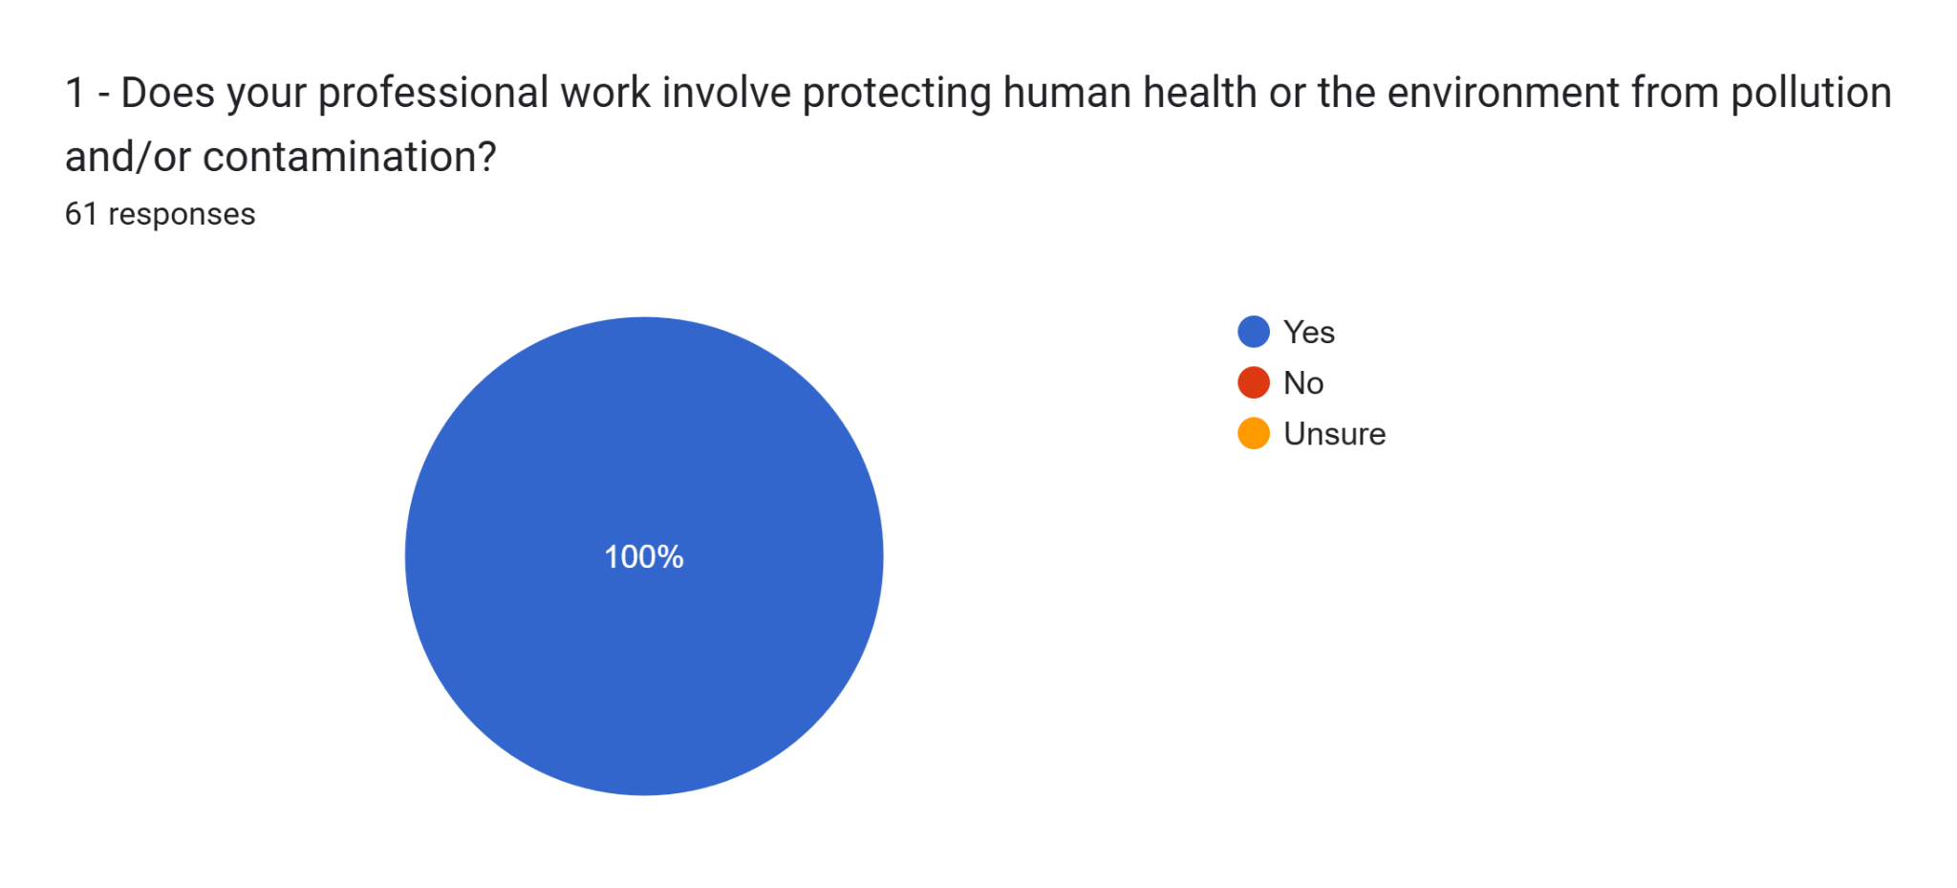

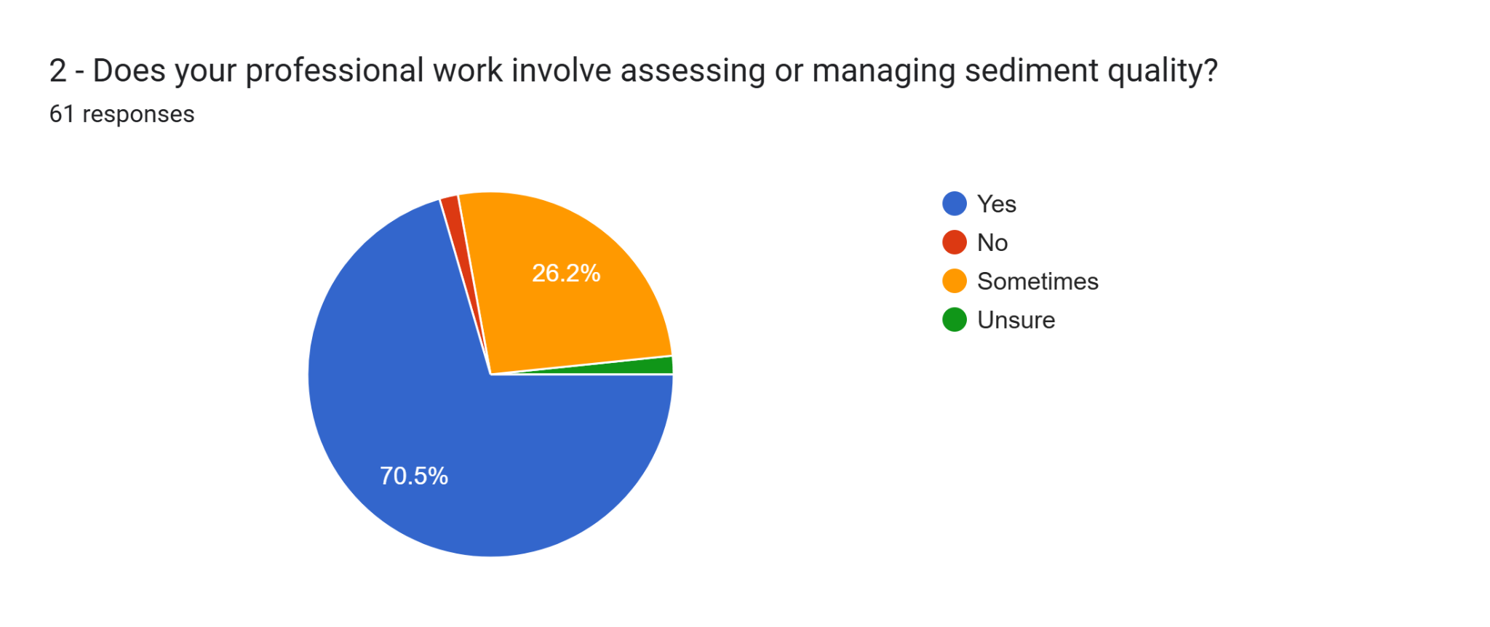

### Section 3: Current BC CSR Sediment Standards (Schedule 3.4)

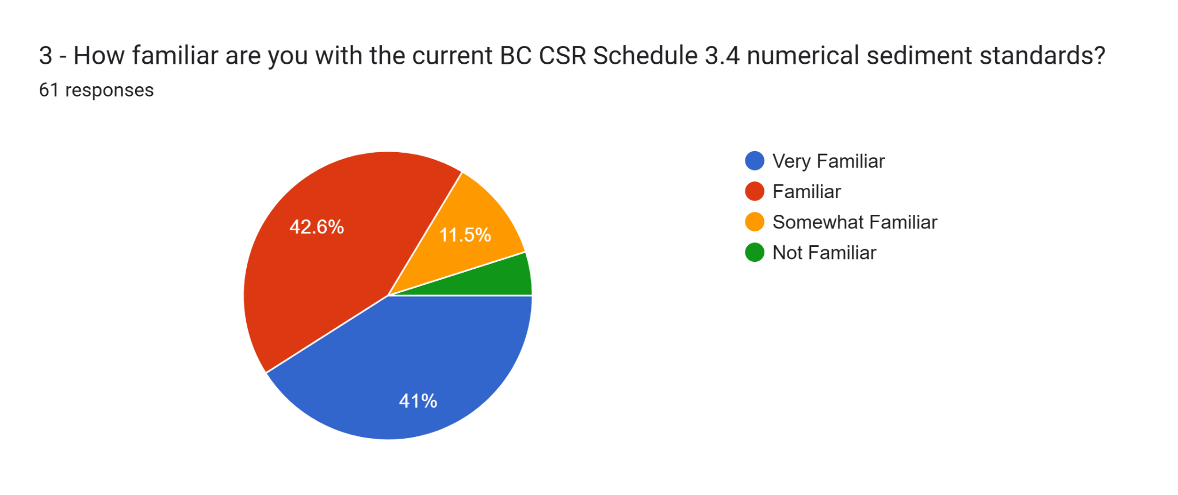

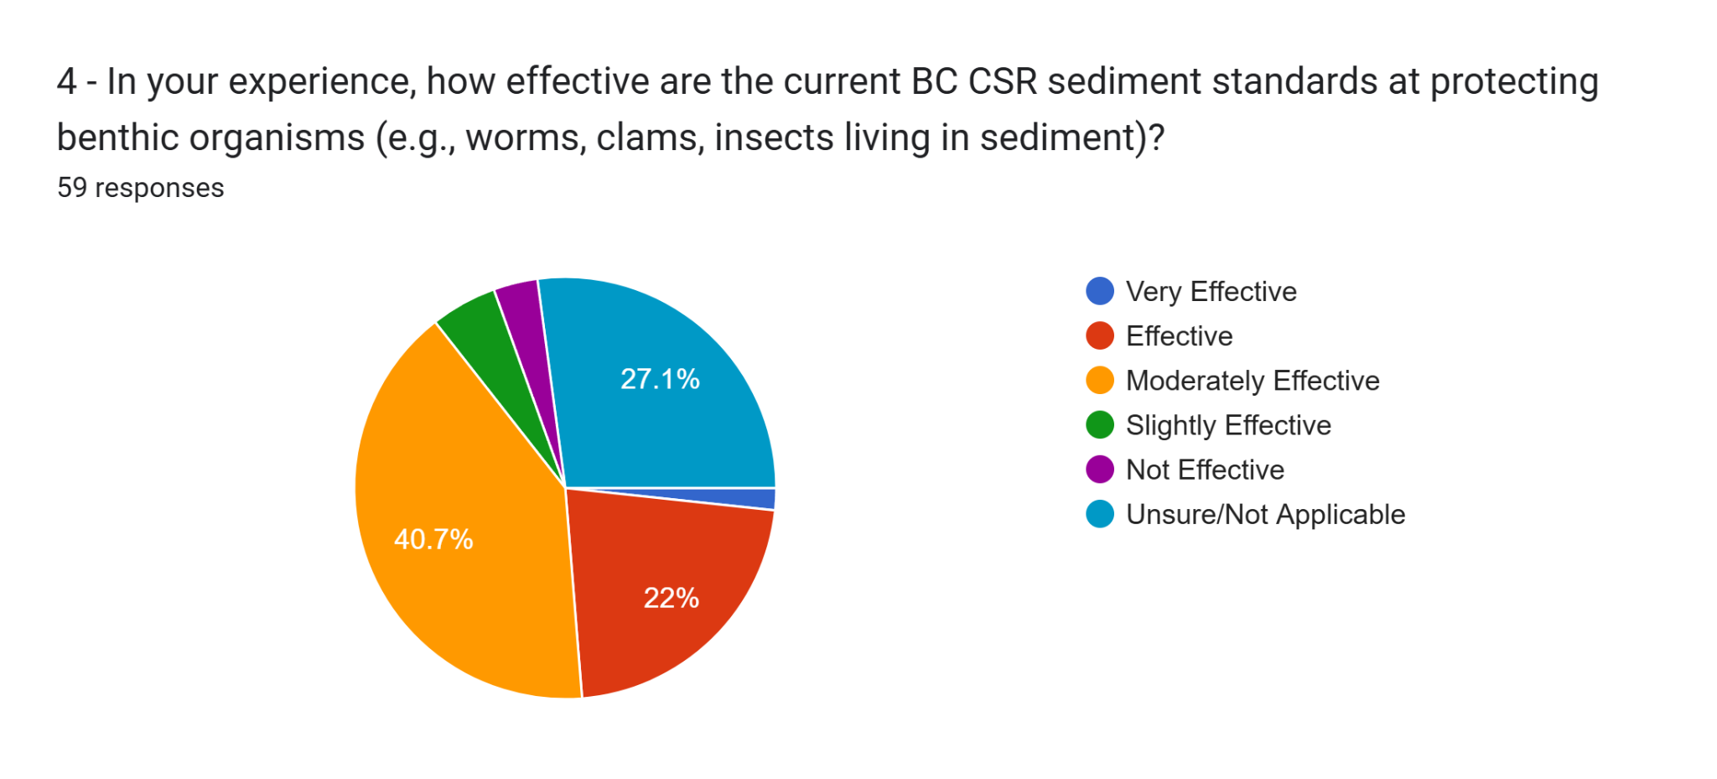

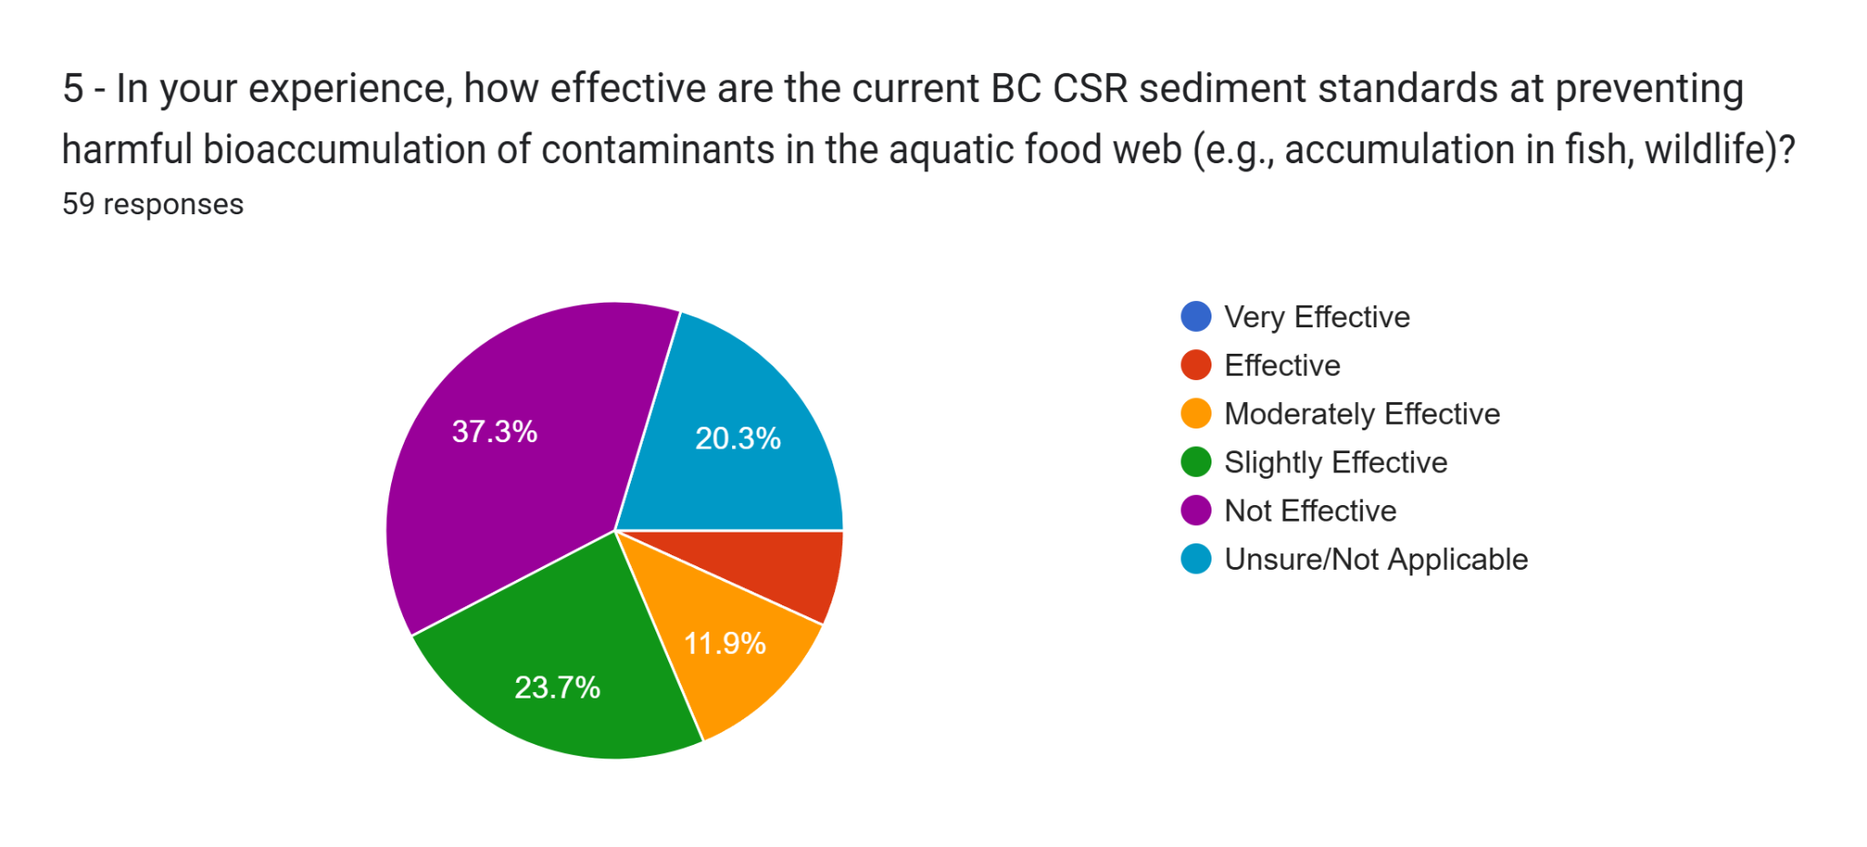

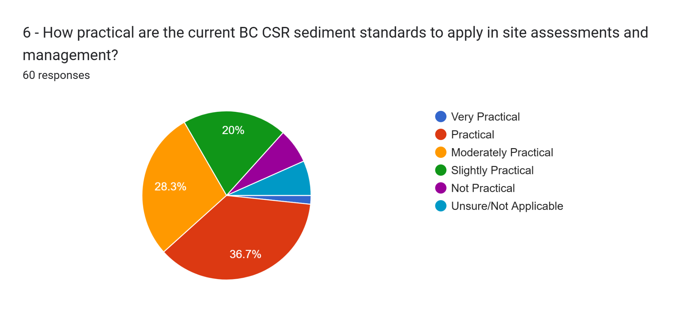

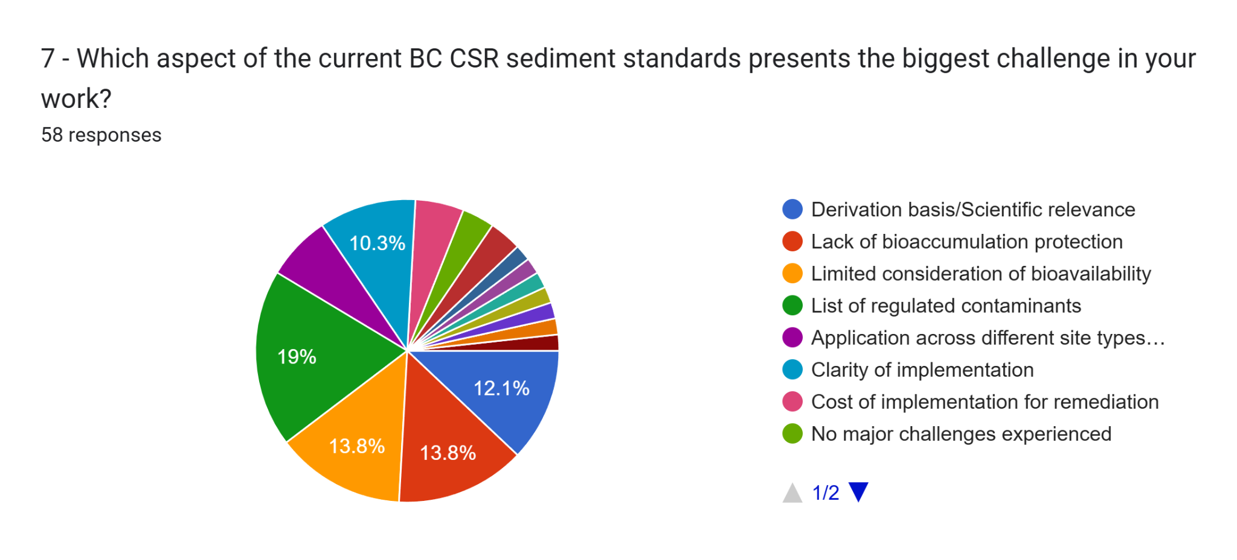

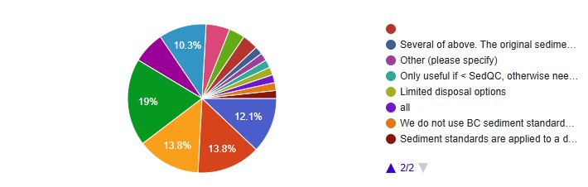

Other responses included:

* All
* Limited disposal options
* Sediment standards are applied to a discrete area; but sources are often associated with the region or waterbody rather than the direct upland parcel. Sediment transfer through a waterlot or other temporal conditions are not considered within the simple 'typical/sensitive' framework.
* Several of above. The original sediment criteria derivation documents were removed from the BC ENV website and should be re-posted or alternatively post a good description of their basis similar to what is at the start of this survey. The current definition of substances that are bioaccumulative (e.g., BCF > 2000) is not that protective. No consideration of % organic carbon although BC Working sediment guidelines have incorporated that for PAHs. Lack of standards for petroleum hydrocarbons (diesel/F2) given how common a contaminant this is.
* We do not use BC sediment standards in our work, but our understanding is taht the basis of the derivation is old and does not consider bioaccumulation.
* Other: Only useful if < SedQC, otherwise need ERA

8 - Please elaborate on the biggest challenge you identified in the previous question, or describe any other significant challenges you face when applying the current BC CSR sediment standards. (54 responses)

* three issues: the standards are outdated and the list is limited, the standards should consider bioaccumulation for substances that bioaccumulate (but only where there is a receptor - I am worried that there may be applying bioaccumulation in non fish-bearing streams), Bioavailability can be considered, but is it only for site specific consideration (e.g. in a DERA)
* Exceeding a standard for a particular substance is almost irrelevant without the context of bioavailability (eg. AVS/SEM, organic carbon)
* Many industrial sites alongside waterbodies have wharves and docks. Sediments in the vicinity of these structures are often contaminated with PAHs from creosote pilings and potentially metals from vessel antifouling paint or hydrocarbons from vessel bilge water, fueling spills, etc. Wharves and creosote pilings are not a CSR Schedule 2 use. Perhaps they should be, in order to officially trigger the need for sediment investigation specific to these structures/use.
* In order of priority, I believe the list of contaminants needs to be greatly expanded beyond the 32 standards, especially as many jurisdictions are focusing energies on newer/emerging contaminants in sources such as CSOs and WWTP discharges. The standards should also be considerate of bioaccumulation -- with particular emphasis on those contaminants where there is obvious evidence of bioaccumulation, with less emphasis on substance where the evidence for bioaccumulation is limited. I think worrying about bioavailability falls in the "additional study" category, or risk assessment, and it may be a slippery slope to try and consider bioavailability given the number of variables affecting it.
* Clarity of implementation. Secondly how determine contamination impacts from the site, background or off-site sources.
* The CSR has long been flawed regarding handling standards which are less than common background concentrations in soil and groundwater. Arsenic in soil is the classic example, along with manganese and iron in groundwater in the interior, particularly near reducing environments such as wetlands. The use of the 95th percentile to calculate background concentrations leads to a background less than the highest background concentrations, meaning that some amount of remediation or risk assessment is almost inevitable. For a new sediment regime, these issues should be avoided through widespread sampling to better capture and understand of the variability of metals concentrations across the province, and more flexible and realistic background concentration calculations. Consideration should be made for biological processes that can accumulate metals (eg, iron reducing bacteria near a spring). Finally, excavation of sediment from wetlands and lakes will lead to habitat loss, as the difficulty of restoring these habitats means that leaving the contaminant might be less harmful to ecosystems than removing it.
* True sediment COCs are not always identified as bioaccumulation is not considered at the investigation stage. This is because bioaccumulation is generally not considered with respect to standards development.
* We are very interested in path-way specific screening criteria for application in risk assessments
* It's difficult to know how the standards were derived, so it's impossible to tease apart the tox data involved to verify the validity to a particular site. It's understood that the tox data is protective of benthic invertebrate community, but nowhere is the level of protection provided. No bioaccumulation protection is also a scary consideration, resulting in the need to clean up to levels below standards but having a challenging time making the convincing argument.
* I agree with ENV's desire to include TOC and AVS-SEM to adjust SedQC in T1 for relevant contaminants (before moving to T2/T3 ERA) and also agree that SedQC for bioaccumulation would be helpful for a subset of contaminants (not necessary for all)
* The standards only being protective of benthic organisms and not higher trophic levels is a huge limitation and leaves much of the ecosystem unprotected.
* the schedule is limited in chemicals and application across different sites
* Clarity between sensitive and typical use
* Marine sediment standards are not available for many chemicals and there is no requirement that the freshwater values must apply in their absence.
* sensitive site use definition is too broad which prevents typical site use standards from being used at more urban sites like marinas, ports, industrial waterfronts. also there are no background concentrations for sediment which should be considered in urban environments.
* The bioavailability in sediment helps us understand not just how much contaminant is present, but whether it is causing harm or influencing environmental processes. This distinction is required to make informed decisions in managing contaminated sites, protecting public health, and maintaining environmental sustainability.
* The two biggest challenges are with Clarity of Implementation and Derivation basis/Scientific relevance, in particular clarity and rationale for when to apply typical versus sensitive standards. In the original derivation (early 2000s) it was understood that typical standards applied at most contaminated sites and the sensitive standards apply under specific situations (refer to Schedule 2 of Criteria for Managing Contaminated Sediment in British Columbia - Technical Appendix. However more recently, BC ENV has indicated that the sensitive standards apply at almost all contaminated sites, but no scientific basis or rationale has been provided. In my experience and from discussions with colleagues, the sensitive standards are overly conservative and don’t provide an accurate screening tool. Often background concentrations exceed the sensitive standards. Also, effects in lab testing or in situ are typically not observed until the typical (not sensitive) standards are exceeded at a meaningful level. This means that screening with sensitive standards at all sites as the default requirement, does not contribute meaningfully to the understand of potential sediment risks.
* Other challenges are the lack of sediment standards for multiple contaminants and the lack of bioaccumulation protection - usually we have to select or own sediment screening values (e.g., apply soil standards or get from other jurisdictions) for non-scheduled contaminants and do some sort of food chain assessment.
* The BC CSR sediment standards are not appropriate or adequate to protect upper trophic level organisms, apex predators and humans at the top of foodwebs, as these sediment standard were or are designed for the protection of low tropic level species and benthic organisms.
* currently the contaminant list is limited. needs expansion
* limited list of regulated parameters and no sediment background
* There are currently sediment standards for 31 parameters, including 7 metals. This makes it more difficult to interpret the results of toxicity tests and benthic invertebrate community surveys. It also leaves open the possibility that sediment impacts go unremediated. To me the first priority should be expanding the number of regulated parameters...including emerging and common parameters. Second priority should be development of standards for bioaccumulative substances for consumer protection
* Unless you do risk assessment work, the current system skews to classifying wide areas of sediment without any way of refinement to reduce, target "hot spots" thus inflating remedial costs to treat a large area.
* limited list of contaminants in 3.4 standards.
* Limited disposal options for material making appropriate disposal cost prohibitive thus leading to illegal dumping
* I think the scientific relevance and the bioavailability concerns both usually warrant discussion when working with various stakeholders. When dealing with a “hard” value it is ‘easy’ to poke holes in the standards or in other cases rely too heavily on them. Adding context to the values (through evaluations of bioavailability, understanding the basis (and limitations) of the standards, etc) - I feel is the only way to get more scientific clarity as to actual risk.
* The removal of contaminated sediment from one location in the sea (ie boat launch) and then the requisite need for laborious time consuming permitting and sampling program to meet a 'disposal at sea' standard ' is pretty haywire.
* Very little petroleum hydrocarbon F3/F4/HEPH standards in Canada. Current standards for PHCS are in Marine canada using petrotox model (fugacity model) are too low (not realistic) and poorly resolve natural (organic matter in sediment) vs anthropogenic.
* Multiple aspects listed above present challenges. The "Criteria for Managing Contaminated Sediment in British Columbia" (circa 2004) is undated and appears to no longer be available. All sites seem to meet the definition of "sensitive". Schedule 3.4 is limited to 31 substances - bioaccumulation is not addressed, nor is human health protection (except to the extent that the default is to apply soil standards based on soil ingestion). The current standards lack ecological relevance beyond benthic invertebrates. The current standards do not account for physical variables such as grain size, or porewater concentrations (which speaks to bioavailability). Requirements for submissions made to ENV for review have been inconsistent, and the need for and extent of weight of evidence approaches and food chain modelling seem to be dependent on who the ENV case worker is.
* Sediment standards are applied as "bright lines" and {likely} conservative in most situations - these factors, combined with the high costs of triad-type analysis stall out attention to contaminated sediments. As a result, responsible parties tend to avoid these liabilities unless forced otherwise. Consideration could be given to better guidance on methods to assess bioavailability through both desktop (OC, modeling, AVS, grain size, etc.) and field methods (benthos, tox testing, tissue concentrations, etc.). Much of this guidance ALREADY exists, so I would argue to liaise with others on this - like Suzanne Agius at Environment Canada or what the Australians just put out https://www.waterquality.gov.au/anz-guidelines/guideline-values/default/sediment-quality-toxicants
* n/a
* The standards do not really take into account when Groundwater/Surface water moves from above "an area" could be a project area (stripped? Mined? Borrowed from?) through to the bottom side of "an area" say a project area. Water quality can be taken at a snapshot in time to determine if sediment studies need to be taken however there is not a real road map as to when this may need to occur?
* Lack of criteria for many contaminants, lack of studies to update SSDs, need bioaccumuation approach
* Clarity of implementation which results in cost increase
* one significant challenge is the inconsistent application of sensitive vs typical across practitioners
* A significant challenge in applying the BC CSR sediment standards is deciding between sensitive and typical sediment use at sites with creeks and ditches. These areas can serve both ecological and functional purposes, creating ambiguity. Clearer guidelines or examples would help in making consistent and effective decisions in these mixed-use environments.
* The NSTP approach used in the derivation of CCME sediment quality guidelines (which were used in the development of the B.C. sediment standards) is outdated. Better sediment toxicity data is now available for most contaminants, which allows for the use of better, more modern methods of guideline derivation such as species sensitivity distributions.
* emerging contaminants
* The biggest challenge is the reliance on co-occurence based approaches to derivation, essentially adopting CCME values that have a high percentage of false positives in practical application (this is different than the statistical procedures used to to process BEDS data). For some chemicals, the standards align reasonably well with field validations (e.g., total PAH) whereas other cases yield high numbers of exceedances that do not validate for the stated protection goals (e.g., several individual PAHs, total PCBs). The fundamental problem is derivation of individual benchmarks using data based on mixtures. I have other concerns, but the questions identified in the survey suggest that they have been identified (e.g., missing substance groups, discernment between direct contact and bioaccumulation pathways, toxicity modifying factors). I will add one new issue here, specifically the role of individual versus substance groups (individual PAH, HPAH/LPAH, total PAH, mixture-based metrics like narcotic and bioavailability metrics), because the standards have inconsistent use of group subtotals.
* Substances encountered on a regular basis are not regulated
* Application of Typical vs. Sensitive Criteria. Current definitions are overly restrictive and impractical for sites that are working harbours and will remain as such.
* River sediments adjacent to an upland contaminating facility; initial samples indicate some CSR standard exceeded; subsequent evaluation indicates that the sample represents the sediment travelling downstream rather than impact from the upland facility.
* Remediation of Sediment is a difficult and rather unregulated body of work with limited access to professionals experienced in that form of remediation and quite costly, especially on large-scale projects. Another significant challenge is the applicability of the regulations to sediment across different ecosystems. Many polycyclic aromatic hydrocarbons occur naturally in sediment containing high decomposing plant materials, and such may occur in higher concentrations in wetlands or in shallow waters with deadfall as opposed to a flowing stream.
* Like the concept of tiered sedQGs or requiring analyses of parameters that can be used to evaluate uptake potential…whether that leads to modified guidelines or sediment LOEs beyond sedQGs.
* Application of sensitive and typical
* Sediment types vary widely
* I selected 'Limited consideration of bioavailability' above, but the challenge I see is that the concentration of a contaminant in bulk, dried sediment is often a pore indicator of the degree of harm that the contaminant is doing. For small organisms that spend time in the sediments but that don't consume significant volumes of sediment, contact and/or ingestion of pore water is the dominant exposure pathway. A Tiered approach, that recommends investigation of pore water quality for substances known to partition into pore water would be helpful.
* While typical sediment standards are provided, they are essentially prohibited from use. Clear and applicable freshwater and marine sediments would be relatively easy to apply yet remain flexible and appropriate to the primary sediment environments. Estuarine standards could be defined as the most stringent of both regimes for each substance.
* very limited list of contaminants - missing most current use pesticides, sewage related contaminants (personal care products and pharmaceuticals)
* Certain chemicals may simply be screened out in an RA as the standards don't trigger inclusion, and as such, the risk to higher trophic level species may be missed. Lack of bioavailability may result in excessive extra work addressing chemicals that simply may not be as bioavailable and could be screened out. The typical vs sensitive approach is a bit clunky. At the very least, the terms don't seem appropriate. Benthic organisms in Industrial harbours may still be sensitive even if there's a lower protection goal allowed for those environs. Like the soil quality standards, perhaps BCENV might designate 'broader areas' in the province with certain protection goals. A shaded map that acknowledges broader zones with lower protection goals perhaps due to accepted impacts from other beneficial use by humans? How would this fit with federal management responsibilities, aboriginal rights and title, etc. These provide challenges to the practical application of sediment standards. Something that meshes better with federal jurisdiction would be VERY helpful. Less overlap.
* Tributyltin/Organotins are a major contaminant in marinas/harbours/shipyards. High priority to develop either a sediment-based guideline or other risk-based media concentration limit.
* Other challenges include the protection of food-web exposures.
* One more challenge is the PROTECTION OF HUMAN HEALTH via INCREASED dermal adherence rates to intertidal sediments. Adherence rates can approach 10x higher than terrestrial soil dermal adherence rates. I've identified unacceptable human health risks through cross media exposures via this method. This is a gap in the regulations.
* Funding to conduct a benthic survey of False Creek's seabed.
* There are numerous COCs that are not within Schedule 3.4 including TBT. Additionally, there are no human health considerations for sediments.
* The CSR list of sediment standards is surprisingly short.
* Protocol 1 indicates that in an HHERA we need to consider the potential for bioaccumulation/biomagnification. If we determine that a COPC has the potential to bioaccumulate (per the definition provided in Protocol 1), then we have to compile lines of evidence or complete a full food chain model to determine risk. It would be nice to have a screening tool (like a sediment standard protective of potential bioaccumulation) as a first pass to focus on more detailed assessments of the risk-driving COPCs.

9 - Can you provide examples from your experience where the current standards may have been under-protective or over-protective? Please provide the context. (44 responses)

* n/a
* In instances where the csr does not have a sediment standard e.g. tributyltin
* Several metals exceedances that had to be further investigated with AVS/SEM to learn they weren't bioavailable (ie. standards were over protective). Extra resources were used to prepare a risk assessment that would not have been necessary if that information could have been used from outset of investigation.
* Under protective - absence of standard for diesel/F2. I have seen amphipod toxicity/lethality in the range of 1000 ppm F2 that didn't appear to be PAHs related. Over protective - possibly the sensitive standards for metals in particular some of the metals that are more natural (CCME ISQG), rarely do laboratory toxicity tests show >EC20 effects for a slight to moderate exceedance of sensitive/ISQG.
* This question seems specific to the numerical values themselves. As these values are not protective of bioaccumulation, there are projects where contaminant concentrations were below standards but tissue data suggested contaminants were accumulating in tissues above critical tissue levels.
* sometimes background sediment metal concentrations are higher than than the standards.
* unable to do so for sediment. I have quite a few examples of soil and groundwater standards being overprotective, and would rather see those problems avoided.
* Not sure if totally relevant, but the definition of a sensitive site is very stringent thus most sites have to have sensitive standards applied. To me, this is overprotective in a number of cases and can result in physical remediation, which may actually be more harmful...
* There has been some recent ambiguity around whether the change in wording on the provincial website meant that CSR supported the application of sensitive criteria at a working harbour or other commercial/light industrial waterlots
* It's difficult to know if they are over or under protective when derivation methods and data isn't available to evaluate. I know that there have been instances where arsenic and copper concentrations in the Fraser River are naturally higher than the standards, so this would be an example of overprotective.
* Mostly over-protective; ERA often indicates neg-low risk (acceptable) even though contaminants > SedQC
* Whenever the standards are applied, they are not protecting higher level species, and this occurs every time they are relied on.
* under-protective in that not all potential contaminants are listed compared to those for water and soil
* With the current definitions sensitive use standards are being applied in almost all scenarios because the definition is so broad and the definition for typical is just “not sensitive”
* Iron is problematic when it migrates to the marine environment due to the precipitate that forms, but not iron standard exists for marine sediment, or for the precipitate. Since legally, this is not an exceedance, it is difficult to get RPs to address it.
* Over-protective - sites in Burrard Inlet, small craft harbour marinas. Since the standards currently are generic they are protective and most risks assessments would develop higher risk based numbers.
* North coast of BC where D&F at moderate to low levels in sediment were causing significant concern to local community. Detailed bioaccumulation assessment and tissue residue analysis demonstrated that the substances were not bioavailable.
* Even the typical standards are almost always overpredictive. I can think of multiple examples for freshwater and marine assessments where the typical standards were exceeded but there was little or not toxicity and little and not measureable effects to benthos in situ. For example at a current marine site I am working at near Nanaimo we have up to 8-fold exceedance of chromium, copper and lead typical standards - however we have only mild uncertain sublethal responses in test organisms and only a limited response in benthic community at one station. None of the lab effects or in situ responses correspond to concentrations of these metals suggesting they are not the cause of effects.
* The best example as showcase is the lack of protection and under-protective approach for endangered Southern Resident Killer Whales (SRKWs) and Chinook salmon in their critical habitats an home ranges in British Columbia. Please, see Alava et al. (2012; https://doi.org/10.1021/es303062q), in which we provide the rationale to address this issue with current Sediment Quality Guidelines (SDG) at the provincial and federal level to contribute to the derivation of sediment quality criteria and tissue residue guidelines that protect biota of high trophic levels under various PCB management scenarios. The results further demonstrated that current PCB sediment quality and prey tissue residue criteria for fish-eating wildlife are not protective of killer whales and are not appropriate for assessing risks of PCB-contaminated sediments to high trophic level biota.
* no
* where parameters exceed soil standards in the uplands but there are no applicable sediment standards; we get forced into risk assessment which is expensive
* Mercury - probably protective of benthos but unlikely protective of consumers; Total PAH - not clear how total PAH can have a higher standard than individual PAHs
* Woodfibre - LNG Plant assessment where the extent of impact was very extensive and there was no way to differentiate between pre-existing sediment impacts given the proximity of the project to the Squamish estuary impacts to the north or to create/describe "background" sediment quality.
* I have worked on numerous projects where it is likely the risk of certain sediments we’re overestimated. This was really only evident when using other metrics (toxicity testing, passive samplers, bioaccumulation assays etc). However the concept and use of these techniques are still quite novel, expensive, and the overall usefulness can be somewhat limited or difficult to convey to the general public. As a consultant, it does feel like a bit guilty to proven innocent when a standard is exceeded (and understandably so). Further work to better understand what these exceedances mean and weight of evidence approaches to better that characterize that risk would be useful.
* A recent boat basin collects river sediments and these become fouled by permitted pleasure craft docking and launching. It seems a bit silly to permit this activity but then punish the operator/owner through onerous sediment sampling, testing and disposal at sea requirements. Its not like anyone is eating benthos at the location, and even were sport fish preying on benthos, the risk of bioaccumulation would appear to be small.
* Sediment in freshwater creek near an upstream oil and gas wellsite in NE BC.
* The standards for Total PAHs exceed the sum of the thirteen individual PAHs and thus, one or more individual PAHs always exceed before Total PAHs exceed (i.e., what purpose do the Total PAH standards serve?). The assumption is that all individual PAHs exhibit the same adverse effect (narcosis) and are weighted equally, which is overly simplistic. There is also an issue of the "rounding rule". There continue to be challenges with toxicity equivalency for dioxins/furans and PCBs (e.g., BC Lab manual approved methods may not achieve the lab detection limits for some individual congeners that are needed to properly assess the TEQ sums), and thus the level of protection afforded and conclusions regarding adverse effects are unclear. Cumulative/additive effects of metals, pesticides, etc. are not addressed by the current standards. CSR sediment standards are commonly not in sync with the BC Water Quality Guidelines values (i.e., Water Quality Branch "Working Sediment Quality Guidelines") and it is unclear why they differ (other than policy decisions from different branches of ENV). Schedule 3.4 only includes 7 metals vs. several other CSR substances prescribed in other media than sediment that have Working Sediment Quality Guidelines (e.g., iron, manganese, molybdenum, nickel, silver).
* Without getting into site-specific data and conducting primary data analysis, I think it is difficult to respond accurately to this question. The fact that most well-done sediment quality triad assessments result in reducing the areas requiring remediation indicates that the current standards are a screening step -- labeling that as under or over protective isn't helpful framing...
* Standards could be overprotective in natural settings that will remediate themselves over time. Sometime clean-up causes more harm than good. Standards may not be robust enough in cases where a long term project is taking place with different substances being used at different times for different durations. more stringent standards could potentially be effective in this scenario.
* Over-protective for metals commonly found in natural geology of the area, particularly copper and arsenic
* In our recent work at the National Guidelines and Standards Office (ECCC) in sediment guideline derivations, we used both an NSTP approach and an SSD approach. The different approaches resulted in guideline values that were different by several orders of magnitude with the NSTP values being under protective for the one chemical trialed thus far.
* Most experience is over-protection, although not to same degree as CCME ISQG (one advantage of BC guidelines, along with total PAH standards). I have too many experiences to recount here, but over time it has become evident that the standards are often too low for direct contact pathway. This is by design, in order to screening data for subsequent investigation, for some cases yield "exceedances" under near-background conditions, leading to inefficiency. On the flip side, the absence of standards for some groups (PBDEs, organotins, etc.) means that those groups get less attention than warranted (i.e., implicitly underprotective if they do not exist). In working harbour assessments, the federal government has adopted the Tier 2 (PEL equivalent) for screening, which seems to work effectively, so I like the idea of keeping multiple tiers. The challenge seems to be more for remote or sensitive environments where the preliminary screening often identifies multiple substances that create appearance of hazard, when such is an artifact.
* Generally overprotective
* Under-protective as many parameters regulated under Schedules 3.1 and 3.2 do not have sediment standards and aren't necessarily included in RA in BC. Bioaccumulative parameters - what is the list specific to marine vs. freshwater, standards to not account for aquatic wildlife ingestion and uptake for bioaccumulative and non-bioaccumulative parameters.
* See previous question. Sediment standards for PAHs over-protective in some cases where natural decomposition occurs at a rapid rate.
* Generally, current sedQGs are likely overprotective but all are weak and have high uncertainty.
* Using sensitive standards for highly industrialized areas
* overly protective as not bioavailable at the site.
* Under-protective often due to the small number of substances included.
* Looking at country foods consumption of crabs under indigenous rights and title with respect to harvesting allowance, crab consumed at regulatory default consumption rates from a major BC harbour would result in unacceptable risk levels in humans. As such, the sediment standards alone do not appear to be sufficiently protective of people if they wish to exercise their full rights.
* See #8 for human health. Context is a small craft harbour boat grid. Dermal exposures to arsenic in intertidal sediments using the default terrestrial soil adherence rate (1E-07 to 1E-08 kg/cm2-event, Health Canada 2024 PQRA Guidance) did not result in unacceptable risks. However, assuming "wetted" sediment adherence rates(6.3E-07 to 6.6E-07 kg/cm2) resulted in unacceptable risks and the requirement for risk controls.
* See above
* Both have been true in different scenarios. I think understanding the limitations of the standards and carrying forward that uncertainty for further evaluation in a risk assessment is key to determining actual potential risk and appropriate protection of relevant receptor groups (human and ecological).

10 - What specific data gaps have you encountered when assessing sediment quality relative to the current BC standards?  (41 responses)

* n/a
* typical vs sensitive sediment - perhaps should have just one standard for all sediment, Sched 3.4 is limited.
* Several substances do not have sediment standards (eg. TBT, NP and NP ethoxylates) that probably should, and require use of standards/screening levels/guidelines from other jurisdictions
* Absence of PFAS criteria; absence of bioaccum considerations, and limitations in the number of analytes.
* what is background and what is contributed from off-site sources
* Pathway-specific guidance, human health effects, organotins (TBT and others), bioavailability
* Gaps in emerging contaminants
* Bioaccumulation
* Standards don't incorporate modifying factors such as organic carbon content.
* Accounting for background soil concentrations in areas with manmade water bodies
* Marine standards, extra receptors not protected with current standards (wildlife, seafood consumption, human health exposure), background considerations, investigation guidance
* applicability of sensitive use standards where typical is likely adequate, lack of background concentrations
* Lack of standards for many substances.
* Bioaccumulation pathway not included in sediment standard derivation; also would be very helpful to have a screening process for whent the bioaccumulation pathway needs to be assessed, it is not necessary for all contaminants. Sediment standards lacking for most of the contaminants in the CSR (for which there are water and soil standards).
* Empirical contaminant data for prey species and predators to corroborate model outcomes in foodweb accumulation model and in some cases updated sediment contaminant date for the suit of POPs and emerging contaminants data, as well as total organic carbon (TOC) content, and the lack pf contaminants (POPs) toxic effect concentration thresholds in top predators (e.g., marine mammals) to be used for deriving SQGs and standards other than those available for PCBs.
* limited parameter list
* ambiguity with how to deal with the area between high and low water mark; lack of parameter specific standards and so being forced into risk assessment; no human health standards
* Lack of transparency in data upon what standards for individual parameters is based (i.e., P28)
* The bioavailability component is a big one. However, literature is limited and can be difficult to interpret. More bioavailability toxicity related studies (ie determining bioavailability related chemical toxicity thresholds) are needed.
* There seems to be less biotic tissue sampling information available to the scientific community and public. The feds and province seemed to do more of this in the 1980's when I started my career. Maybe it is more common than appears but the data is not appropriately shared. I reckon that if the taxpayer is paying for it the reports should be made readily available.
* same as question 8
* Transparent derivation process to identify which specific TRVs were used to derive the CSR sediment standards (specific organism(s), level of effects/protection level, whether TOC normalized for organics, use of water quality based TRVs vs. sediment based TRVs).
* 1. Over time, Typical values have come to apply no where now in BC; a gap to fill is reconciling the applied protection levels w policy intent.
  + 2. Conflict with Fisheries Act arises, would be good to have a policy agreement w DFO (!)
  + 3. I don't see bioaccumulation as a data gap in the standards - there are better approaches to screen bioaccumulation than a sediment chemistry measurement.
  + 4. Defining "background" is one of the biggest gaps - we wont improve sediment health in harbours if we defeat proponents w remediation to pristine. The remediation gets stalled out and the opportunity for traction is lost. There are FAR more sediment problems out there that we are not aware of...
* People. People do not test the sediment for the proper items.
* the application of regulations across different streams such as freshwater, marine and estuarian. Its defiantly not the same for all
* Not applicable
* Similar to those already identified in your backgrounder, forcing reliance on other jurisdictions (Washington State, US EPA, EU, or ANZECC) to fill gaps, which requires assumptions about derivation methods and level of protection. The biggest omission in my opinion is total petroleum hydrocarbons, including analysis of mixture type (gasoline, diesel, lube/oil, or heavier). The PBDE, TBT, and PFAS gaps could also be filled, with possibility for BTEX and phenolics also. For some substance groups, the substance group requires evaluation of composition rather than just group total.
* Hydrocarbon standards
* Available BSAFs are not always available for freshwater or marine systems and many use a mix of studies to obtain an "aquatic" BSAF which doesn't account for varyations in uptake mechanisms for metals.
* Not sure what is meant here. When simply comparing bulk sed chem data to sedQGs, not a lot of data gaps or needs. The gaps and needs come into play when assessing other sediment LOEs.
* species relevance
* No nickel guidelines.
* Lack of standards for the broader range of substances regulated in soil or water.
* very limited list of contaminants - missing most current use pesticides, sewage related contaminants (personal care products and pharmaceuticals)
* Not sure if they're data gaps per se, but better guidance on sediment sampling density, use of grids, etc would be very helpful for many.
* Human Health Dermal Exposure (#8 and #9) and wildlife food chain exposures.
* See above
* Not all parameters that should have standards do.
* The potential for bioaccumulation, integration of Indigenous knowledge

### 

### Section 4: Proposed Approaches for Updating Standards

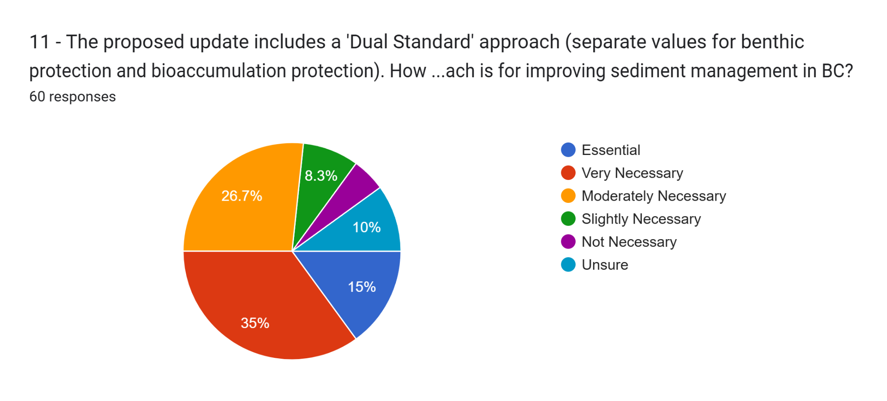

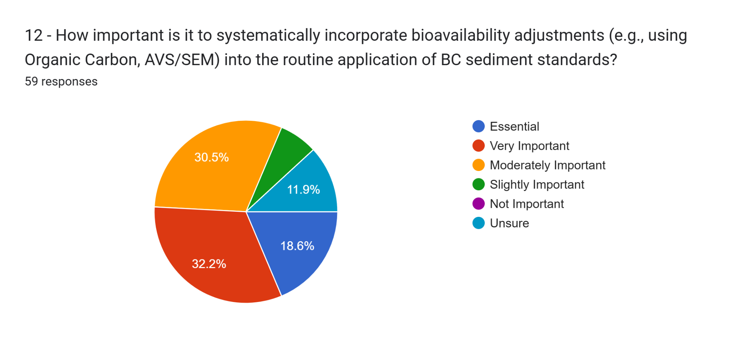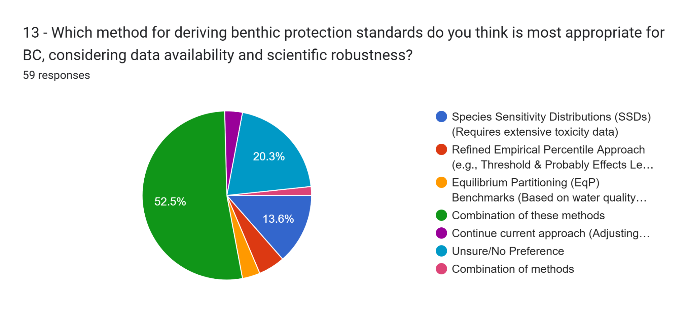

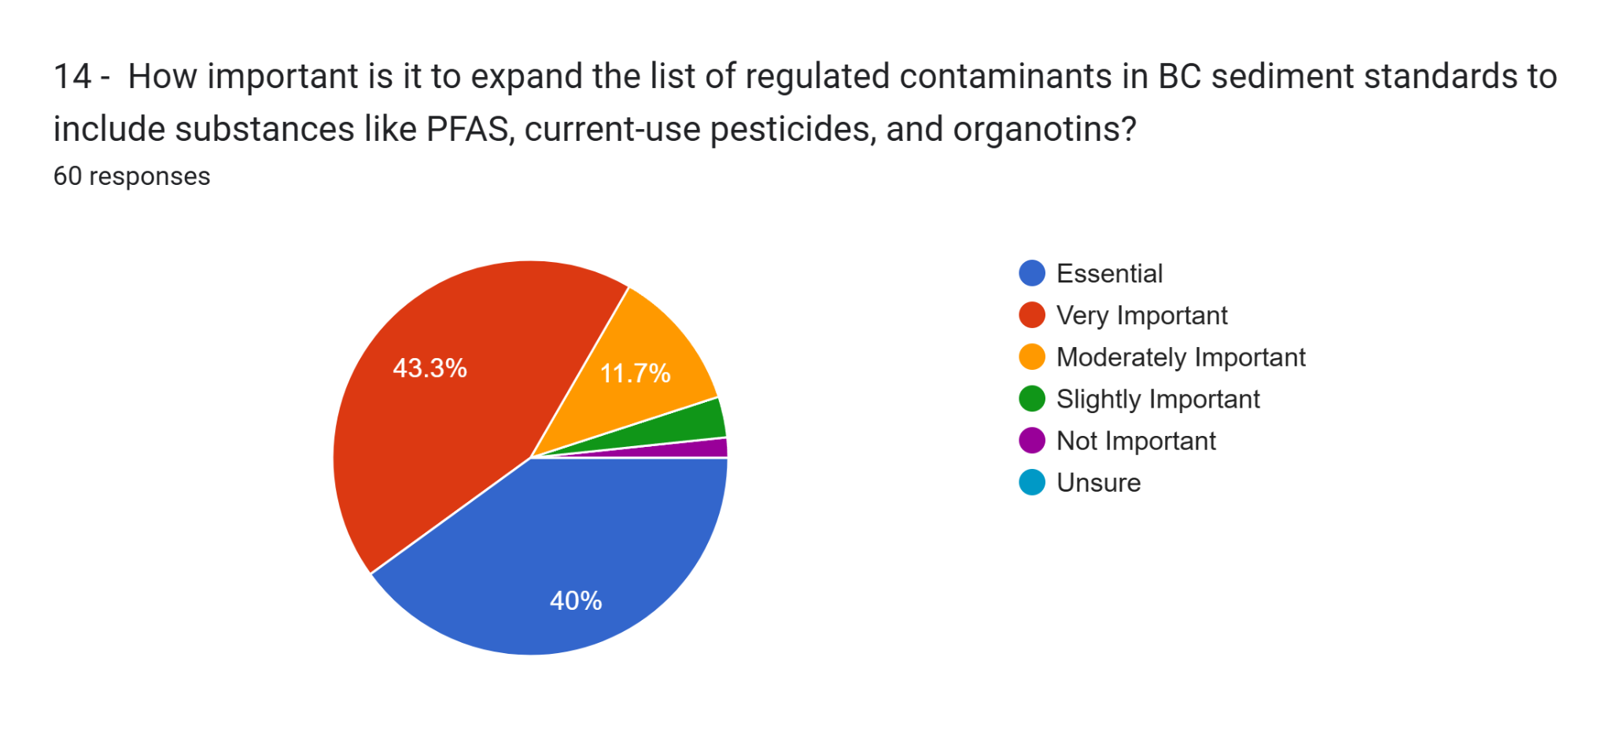

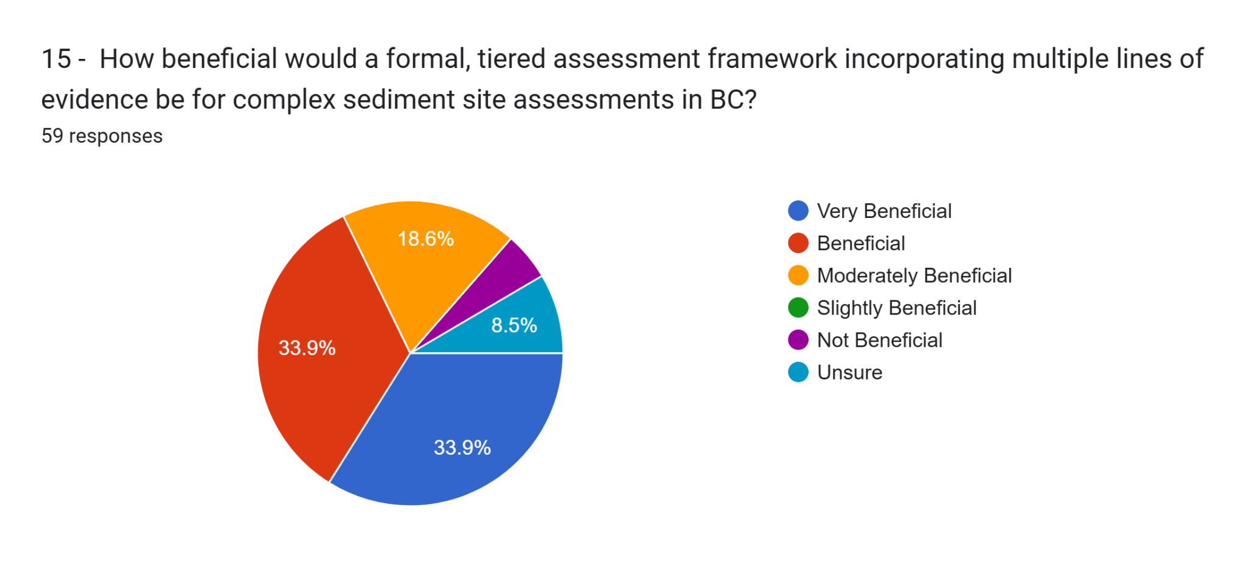

16 - What are your thoughts on the proposed 'Dual Standard' approach? What potential benefits or challenges do you foresee in its implementation?   46 responses

* n/a
* In theory, it seems protective. My concern is that some substances may have low, stringent standards that are difficult to remediate or there may be anthropogenic background influences that will make it not possible to delineate and remediate.
* I like the approach, but may be unclear when to compare to benthic protection only (and not compare to bioaccumulation protection), which could lead to inconsistent application of standards by different stakeholders throughout the province.
* Dual standard approach is a good idea and would simplify decision making for risk assessors. Challenges will be which substances to include, which bioaccumulation factors to use, which wildlife to include, and what human shellfish/fish ingestion rates to use.
* I like it. It does not necessarily need to start off with a massive list of contaminants. Rather it could focus on priority contaminants where there is evidence of significant bioaccumulation concerns based on data supported by human dietary studies, tissue studies, Southern Resident Killer Whales, etc.
* This reminds me of when soil vapour sampling first came out and required soil vapour testing if hydrocarbons were a PCOC, even when soil and groundwater were non-detect. The complexity and cost of sampling versus the benefits needs to be considered. By default, most streams, estuaries and shorelines are crown land, and are subject to contamination from a number of sites. While the polluter-pays aspect of joint and several liability under the CSR is beneficial for sites with defined boundaries, this liability framework is unfair for sediments in a location such as the Port of Vancouver.
* My initial thoughts are that this makes things a bit more complex then they currently are and in general, a simple approach is better as it reduces the chance of improper application. However, given there are soil matrix standards, practitioners are already familiar with a "multiple standard" approach so this may be a mute point.
* This will be very useful in dividing out considerations in a screening-level risk assessment though relevant data needs for some contaminants may be challenging. It's easy to "ask for everything" with this work.
* I think this will address a critical gap in the sediment guidelines although it may not be necessary for all constituents (i.e., those that don't bioaccumulate would be assumed to more toxic to benthic inverts immediately in proximity to the sediments rather than higher trophic levels).
* As indicated earlier, bioaccumulation standards are not needed for all regulated substances
* There could be a lot of confusion as we already see this with the use of the current 'typical' and 'sensitive' sediment standards
* More use of professional judgement
* Having these standards would expedite investigation/risk assessment for some sites. But, it may be difficult to come up with these standards.
* potential confusion on application depending on if it is clear or not
* Sediment sample collection often has related sampling artifacts, such as changes in redox of sediments. What was not bioavailable in-situ is bioavailable ex-situ and visa versa.
* It's only useful if there is a clear definition of what "bioaccumulation protection" means. All chemicals bioaccumulate to some degree. Does this mean "biomagnification protection" and would it apply only to chemicals with a high potential for biomagnification? If yes, then the dual standard approach is important. In my experience the difference between bioaccumulation and biomagnification is not well understood at the regulatory level in BC.
* Fishing and sea food consumption are a major part of BC so a standard that will protect human and other species who are in potential risk must be implemented.
* I think implementing a proposed Dual Standard' approach by separating values for benthic protection and bioaccumulation protection is necessary to benefit the protections of most of the species of the foodwebs and ecosystems (an ecosystem-based approach standard)
* makes sense
* This would be useful for specific bioaccumulative substances but not needed for all. Sediment risk assessments already address substances that exceed generic standards.
* not opposed to the idea, However, I think it would be difficult to not apply the bioaccumulation human health standard without hydrotech/geo assessments. Scope of where the land use applies would need to be very clear.
* Sediments are still - in my opinion - vastly understudied in academics and especially in industry/consulting. I think the dual approach sounds like the first step - and hopefully it will help push the science forward.
* Tendency for government to overuse precautionary approaches making management of material expensive and impractical given risk.
* i agree and like everything proposed, well done
* A dual standards approach would address more receptors (i.e., not just focus on benthic invertebrates). A challenge would be to identify the list of substances that have sufficient information to determine their bioavailability per the definitions in Protocol 1, and sufficient toxicological data to allow for development of standards. There is not currently a list of substances for which bioaccumulation-based standards could be derived, or which might warrant research support by ENV to develop (perhaps the Water Quality Branch has something to contribute in this regard).
* My response to this question depends on the uncertainty in using measured sediment chemistry as a predictor of food chain exposure to eco and HH receptors... I hunch that digging into this will reveal that, except for a few contaminants where biomag is the process, the numbers we would get for bioacc std would be too uncertain or too conservative for use. Would be a good conversation for this group to have and maybe do a thought experiment and trial a metal, a PAH and PCBs, to see how it would work.
* Getting people up to speed and following something like this is always difficult. A good educational plan may be helpful for all industry professionals that are interested!
* provide clear clarity and better findings
* We approve of this approach. This will create guidelines that are protective of entire ecosystems rather than one aspect. The challenges include longer, more complication guideline derivation process, need for more kinds of high-quality data. Thoughts on specific challenges are:
  + - Rather than a dual standard approach, could consider multiple pathways such as done in CCME soil guidelines, which allow certain pathways to be omitted if not operable at a site. The final guideline is the lowest of the pathways.
  + - Suggest separating human health and ecological pathways.
  + - Consideration is needed regarding to what trophic level the guideline protects—primary, secondary or tertiary consumers, or all three? Primary or secondary consumers are often the most sensitive in CCME soil guidelines, but this may not be the case for all chemicals. Might consider separating avian vs mammalian (also aquatic vs terrestrial organisms consuming aquatic species) so certain pathways can be excluded in not operable.
  + - How to consider mobile organisms that might only spend part of the time in a contaminated site (e.g., salmon, whales, etc) as assuming 100% living/feeding at contaminated site would be unrealistic and result in overly conservative and possibly unrealistic sediment concentrations.
  + - This approach will likely only consider trophic transfer from sediment organisms to higher trophic levels, and not additional accumulation of higher trophic level species via water and/or direct contact with sediment. However, given that bioaccumulative substances tend to have low water solubility, uptake from water could be a minor exposure route.
* Generally in favour, especially for substance groups like PCBs and mercury. The problem is that application in a bioaccumulation context requires consideration of scale rather than point by point screening. Not sure how that would work in a CSR or broader context.
* Benefits that both pathways are addressed at sites where they are relevant but not necessarily encumber small sites
* How would this approach take into account sensitive vs. typical criteria. Or would the use of sensitive and typical criteria be retired? This is a bit unclear at this point in the survey.
* Concern rising from clients trying to argue against remediation in water systems not directly linked to human consumption such as small streams or non-fish bearing wetlands.
* Depends on the contaminant, but generally a good idea. Would address a current missing piece where possible, but could confuse users unfamiliar with key ecotox concepts.
* Challenges include cost and timing for clients. I see potential benefits from the process but also see that the dual approach is usually used in risk asessment.
* Bioaccumulation may not be relevant based on site size / species present.
* Helpful, because for small areas of contaminated sediment, benthic protection might be all that is needed. For larger areas of sediment, it would be useful to have bioaccumulation protective standards.
* If it's organized similar to the matrix standards in Sched 3.1, it would be easier to apply.
* I am sure it would be more work and effort to develop this so this is the limitation, but ultimately it would be a more holistic and thorough approach to regulating contaminants in soil and Canada should be incorporating these approaches as to protect all organisms exposed to contaminants via any media. WHO One Health Initiative approach should be the goal while we are developing new regulations.
* I think it's getting ahead of itself at this stage. I would prefer to see a more top down approach that considers better coordination/integration of provincial/federal jurisdiction and responsibility; a more clear set of assessment endpoint goals and for what types of aquatic bodies; consideration of the practical application of standards including time/cost; and of course the latest science with respect to chemical toxicity that considers their typical fate and transport in aquatic systems with priority on the more toxic, bioavailable, bioaccumulative chemicals that are longer lasting in the environment.
* I can see the need for a Tri-Standard approach - human health dermal contact (at beaches and intertidal recreation areas), direct contact for benthic invertebrates, and indirect contact to wildlife through food consumption.
* We - False Creek Friends Society (falsecreekfriends.org) are in the earliest stages of developing capacity to conduct sediment research - but it is essential we do so.
* I believe this can be extremely beneficial, especially when combined with a tiered assessment framework.
* A duel standard approach will make it harder for a QP to evaluate the data in the data, and be sure it is being done the way the ENV wants it. The result is that the lowest of the two standards will because the default standard, and the higher number would be irrelevant. Thus essentially as single standard.
* I like it. We have been trying to incorporate a dual standard approach into the COPC screening other media types. For example, we will incorporate Ontario soil guidelines protective of mammals/birds to screen for bioaccumulation potential and associated risk in the soil COPC screen for terrestrial ERAs.

17 - What are the key considerations for formally linking sediment quality assessment to Human Health Risk Assessment (HHRA) in BC, particularly regarding fish/shellfish consumption? 43 responses

* n/a
* is it not already linked?
* bioaccumulation potential; likelihood of fishing/harvesting in a particular area
* Whether BC ENV wishes to apply human health ingestion based sediment standards and modelling to areas that are subject to DFO harvest closure based on their proximity to marinas or urban areas/sewage.
* I like what was done with the BC ENV Fish Screening tool. If tissue concentrations are about X threshold, then you need to do more work. I could see a fish or shellfish tool, that uses similar assumptions, and back-calculates a threshold in sediment based on HH TRVs and biota-sediment bioaccumulation factors.
* In industrialized areas where multiple polluters and pollutants are present, liability needs to be managed.
* Unsure if this is the kind of thing you are looking for but her is my answer.....Background conditions. Collecting background data to confirm/refute if elevated concentrations are a result of AECs or a background scenario. This may reduce the # of COCs pulled into an RA or possible eliminate the need for an RA. Additionally, wasn't there an attempt to try and get a database going that linked sediment quality to tissue concentrations? It was many years ago, so I might be off base with where that was discussed, but its an idea either way.
* Benchmarking consumption levels specifically in coastal/First Nation communities where consumption rates may be elevated.
* Traditional Knowledge, particularly robust First Nations consumption rates of fish and shellfish.
* Option 1
* linkage needs to be specific to the organism being consumed.
* Sensitive and typical standards are not a good framework for standards. We should have one standard that includes protection for seafood consumption (human and wildlife), and one standard is not (although i don't know where these would apply). Having standards protective of different receptors and uses would help help sites with minimal contamination to not need to do HHRA, or for sites where harvesting is unlikely. HHRA at all sediment sites is overly onerous, and a contaminant threshold (i,e, the standards) should be used.
* away out if the area being worked in is subject to a fish/shellfish consumption ban.
* Substance concentration>bioavailability>aquatic receptor exposure>human consumption (organism and rate of consumption)
* Toxic effect concentration or thresholds for the suit of targeted and.or selected contaminants (PFASs, CUPs, oganotins) along with the WoE of human toxic effects and daily dietary intake rates for fish and shellfish consumption, mainly in First Nation Communities heavily reliant on seafoods.
* are benthic organisms actually harvested for human consumption.
* Contaminant bioavailability, uptake into food, toxicity via food consumption
* establishing that fish/shellfish are actually being harvested in an area.
* na
* Well a baseline in fish/shellfish consumption would be useful. This is what I was doing in the 1980's at Environment Canada. Facts are people are not generally eating shellfish from polluted sediments so it is unclear what the risk is we are trying to prevent. Fish being more highly motile, again unsure what bioaccumulation is going on, although mercury in some species has been a long known problem. Fish limits are so small now, can a person even capture and eat enough of a high risk species to hit a dangerous exposure level?
* biomagnification, protection of teratogenic effects on pregnant people from seafood
* In my experience, tissue data is much more meaningful than empirical extrapolations from sediment to tissue given the inherent site-specific variability in physical properties of sediment, and in the uptake by organisms (e.g., lipophilic substances based on log Kow vs. actual concentrations in tissue which are affected by organism metabolism and excretion; metals speciation such as inorganic vs. organic forms of metals such as arsenic and mercury). Modelled concentrations often grossly overestimate bioaccumulation compared to measured tissue data, and cooked vs. uncooked food. It may be more realistic to have a relatively short list of the most concerning bioaccumulative substances, and where certain thresholds in sediment are exceeded (e.g. > UCCs), have a requirement to obtain measured tissue concentrations (field tissue samples or site-specific bioaccumulation sediment tests with organisms such as clams to see what actual site-specific bioaccumulation occurs).
* Regarding direct contact pathways, Health Canada provides guidance on human health for direct contact with sediment, but there is high variability and uncertainty in sediment to skin adherence and contaminant absorption factors, as well as linkage to grain size.
* Liaison with federal counterparts is essential here, as well as Min of Health and with groups working towards country foods health (e.g., look at Burrard Inlet work) - this is a big ball of wax :) and lots of process before the science. Perhaps this could be a secondary objective to the main focus?
* Population, inffluents into a certain area, does one have a baseline?, how far does this reach?, how many subjects are being followed/studied?
* Not applicable
* For the strongly bioaccumulatives, the main issues are incorporating bioavailability and site-use assumptions (factors that profoundly affect dietary uptake). For metals, the main challenge will be how to incorporate dermal contact scenarios, which are highly uncertain.
* Many contaminated areas are also under harvesting closures
* Tissue residue guidelines over sediment guidelines would help with this barrier. Fish and shellfish have multiple routes of exposure and the magnitude of each (sed, pw, sw) depends on the fate and transport of the contaminant. Tissue guidelines would remove the need to rely on multiple media and have a lower level of uncertainty when modelling risks for humans as the guideline could be used to identify the need to conduct a dietary assessment.
* Isn't most of the BC coast under some sort of shellfish consumption restriction?
* Bioaccumulation should be assessed with regards to species and actual uptake amounts.
* I would not try. Current standards that do this have weak basis and are often not very applicable.…though are very few of them. Leave HHRA out of sediment standards. It is not possible to have a widely applicable approach as too many factors come into play and is too much uncertainty.
* I think this is very site specific and so clear guidelines on how this would be assessed should be considered.
* need current / accurate consumption levels
* On the surface it might be helpful to have sediment standards protective of human health via ingestion of food containing bioaccumulative substances, if the model used is too conservative then the sites will end up going to risk assessment and direct analysis of contaminants in tissues of food items.
* I suspect it will take studies aimed at understanding bioaccumulation factors and field and lab studies for several contaminants and will be challenging due to the number of chemicals currently in commerce. It's possible as these field and lab studies get underway we can develop some model in vitro or in silico studies to test in a more high throughput fashion and site specific studies
* Raw vs cooked state of the food source. Raw tissue concentrations may not adequately describe actual consumed concentrations. Realistic seafood consumption levels relative to regulatory default assumptions. Home range of consumed species relative to sites of interest. Bioavailability of chemicals in water/sediment and bioaccumulation of chemicals into food sources.
* NOt going too conservative with regards to fish/shellfish consumption rates.
* HHRA for False Creek at some point has to produce data for risk analysis for guide to swimming activities for humans in False Creek.
* consumption rates and proportion of collection within an APEC versus other areas.
* Bioaccumulation and bio transfer risks.
* I think there is a relatively high level of uncertainty in modeling / predicting concentrations of COPCs in fish/shellfish from a sediment concentration. Perhaps a screening standard could work, but likely would need to address through multiple lines of evidence in a detailed HHRA.

18 - Regarding a Tiered Approach (e.g., Tier 1 generic numerical; Tier 2-3 site-specific numerical): What site-specific information and lines of evidence (beyond chemistry) are most critical to include? 43 responses

* n/a
* presence of fish, species that take up the contamination, the exposure pathways to humans.
* organic carbon, AVS/SEM; reference site comparisons; tox test data; species abundance data; tissue data
* Depends on the nature of the site and its usage, but sediment toxicity can be useful. BICS is often a headache. We have also started analyzing the tissues of benthic organisms themselves to see if a) they are bioaccumulating the contaminants b) levels are above CTLs.
* Probably irrelevant, but I worry that a tiered approach can be complex and result in improper application. If possible, simple is best.
* Site usage categories would be most useful to hone in on a relevant screening value.
* Toxicity and Biological Community. I think CCME has fairly good, recent guidance on lines of evidence in risk assessment that can be drawn upon to formulate this guidance.
* Relevant toxicity tests and benthic invertebrate communities (standard LOEs in ERA)
* Option 1
* land/water usage - likelihood of exposure to humans
* Scouring potential
* surveys and toxicity tests applicable to each receptor group, i.e. a set of chemistry, toxicity, species surveys for each trophic level and feeding guild. In addition, significant background information is needed for both biological surveys and chemistry. What are the requirements for the background site?
* TOC, bioavailability of metals, type of habitat/land use (urban vs remote)
* I assume you mean sediment chemistry, exposure and uptake
* bioavailability, laboratory toxicity, benthic community structure, food chain assessment, guidance on spatial area of effect and how to link that to population/community risks.
* Critical habitat, species foraging behavior, climate change and cumulative effects with other pollutants (chemicals mixture or 'cocktails') and anthropogenic stressors.
* grain size, organic carbon, AVS/SEM
* TOC, AVS/SEM, toxicity tests, benthic community analysis, bioaccumulation
* na
* The bioavailability aspects are critical, but also receptors and habitat suitability.
* Don't know
* Encourage background sampling to get background concentrations of sediment. For PAHs in select areas, there is a need to differ petrogenic vs pyrogenic PAHs in sediment.
* TOC and grain size adjustments at Tier 1 and/or Tier 2. Porewater concentration data vs. water quality guidelines at Tier 2. Measured tissue concentrations at Tier 3.
* Sediment Quality Triad elements, and room to augment site-specifically w tools like - porewater chemistry and tox, fate modeling in sediment (using mini-CSM tools to build arguments for loadings and speciation), etc.
* Needs to have a map of all influents coming in, in all areas of study. Needs to follow the subjects to ensure that one knows where they have been. A sample of each subject should be taken when tagged for reference.
* Organic content of the sediment, sediment grain size and composition, pH, intended use of the site (i.e., recreation, commercial/industrial activities, etc.), type of carbon, is a pathway operable at a site, any site-specific input values to models that are generally stable, site specific partition coefficients (Koc, Kd). For bioaccumulation consideration, the time spent feeding in contaminated site. Specifics/proportions of diet e.g., 50% small fish, 50% crustaceans. Consideration of aging? This may need to be Tier 3/site specific, requiring testing to demonstrate lack of bioavailability.
* I could write at length on this, but to be concise I will simplify to 1) bioavailability factors; 2) comparison to local reference and background; 3) standardized sediment toxicity tests; 4) functional measures of community health (richness, proportions of major taxa); 5) concentration-response information from related sites.
* toxicity testing, TIE
* Wouldn't this be better to tackle in an update of the 2008 DERA or 2010 SABS WOE documents as opposed to a sediment focused work group? There are other priorities that should be addressed during the PF phase of work with sediment before these come into play. For example - clearly identifying aquatic bioaccumulative parameters, adding unregulated contaminants from other media or newly identified, revising the use of typical vs. sensitive standards, adding a "dual standard" approach.
* Descriptive site-assessment protocols to determine numerical values
* Avs-sem; toc; grain size
* species diversity study, traditional knowledge, taking into account bioavailability (SEM/AVS). I think this should be at the risk assessment level though.
* density / grain of sediment can hinder some species presence.
* Sediment/site use. In particular, is the sediment-containing site likely to be used for recreational or subsistence collection of food items (e.g. fish, shellfish,)
* freshwater/marine status
* understanding bioaccumulation in wildlife at various sites through food chains due to contaminated sediments; toxicity data for multiple species
* Aquatic site size, location relative to other potential sources of contamination (linkage to upland sources if that's the case); lab toxicity of collected sediments; benthic community assessment (at higher tiers, but still needs better interpretation/regulatory expectation with respect to results and their inclusion/application), tissue sampling of food types if the site may be used for country foods harvesting.
* Human accessibility to contaminated intertidal sediments.
* Not competent to answer
* bioaccumulative nature of the COPC, bioavailable nature of the COPC, potential exposure pathway (what is it being exposed to and how is it being exposed)
* potential for recreational use. frequency or likelihood of dredging. Extend of commercial/industrial use (boat and ship usage of area). Sensitivity and value of habitat and local species.
* I think additional lines of evidence should be incorporated into an ERA (not the screening standards). These LOEs would depend on the site and circumstances, but the most useful ones I have used include indicators of bioavailability (AVS/SEM, TOC, particle size, pore water concentrations), toxicity (toxicity tests). I find benthic community assessments challenging to successfully implement due to the variability in habitat types and the difficulty in identifying appropriate and comparable reference locations.

19 - Do you have experience with sediment quality frameworks from other jurisdictions (e.g., US EPA, Ontario, Washington State)? Are there specific elements from elsewhere that BC should consider adopting or adapting? 37 responses

* No
* no
* n/a
* no/very limited experience
* No. Potentially Atlantic RBCA; however, their guideline values for hydrocarbons may be overly conservative.
* No, my experience is largely with BC CSR or CCME.
* We use the TBT guidance that EPA uses, you've already covered considering TOC's effects on bioavailability.
* Not at this time.
* Quite familiar; no need to re-invent the wheel; the actual values don't matter as much as the framework within which they are used
* no not familiar with other jurisdictions. Washington State may be the best example for adopting regulations/guidelines - prior to Trump administration if they have been recently revised.
* Acceptance of applying background values
* US EPA PAH Equilibrium partitioning should be considered when deriving new standards
* Organotins US EPA/Washing State
* USEPA, and Washington
* For marine sediments - Puget Sound / Washington Dept of Ecology has are more extensitve list of contaminants and includes the apparent effects thresholds (AET) which is the concentration for a particular chemical above which adverse effects were always found for at least one of the following four biological indicators:
  + 1. Amphipod: 10-day mortality sediment bioassay; AET = higher mortality than control (p<= 0.05).
  + 2. Larval: mortality/abnormality sediment bioassays using Pacific oyster, blue mussel, purple / green sea urchin, sand dollar; AET = Higher mortality than control (p<= 0.05).
  + 3. Microtox saline extract: Decreased luminescence from bacteria Vibrio fischeri after 15min exposure; AET = light output < 80% control (p<= 0.05).
  + 4. Benthic infaunal abundance: Class crustacea, Class Ploychaeta, Phylum Mollusca; AET= <50% of reference for any of the groups.
  + Also, the Puget Sound / Washington Dept of Ecology approach includes The mean Sediment Quality Guideline quotient (mSQGq) involves dividing all sediment constituent concentrations by respective guidelines and then taking the average ratio.
  + It provides an indication of the potential for mixture toxicity which might not be adequately represented in the screening of individual sediment contaminants.
  + The overall average can be calculated for individual chemicals or for chemical groups (after averaging within a chemical group).
  + I have just experience at the national or federal level for Canada's Three Oceans. For example, see: McTavish, K., Alava, J.J., Brown, T., Crossland, M., Dangerfield, N., Hickie, B., Ross, P.S., and Tillmanns, A. 2024. A Framework for the derivation of environmental quality guidelines that protect apex marine mammals from persistent organic pollutants (POPs). Canadian Technical Report of Fisheries and Aquatic Sciences (Can. Tech. Rep. Fish. Aquat. Sci.) 3582: viii- 28p. https://publications.gc.ca/site/eng/9.931293/publication.html
* none except the TBT criteria from Puget Sound.
* The size fraction aspect still confuses me a bit in BC. US EPA suggests that bulk sediments be evaluated.
* No I only worked with provincial and federal standards.
* Marine Canadas uses petrotox model to PHC sediment standards (i.e F3) and they are far too low and often result in flagging exceedances exceedances that are just naturally occurring organics in F3 carbon range. The model is fugacity based rather than SSD or evidence from tox studies.
* Yes. TOC normalization and grain size adjustment. No others that immediately come to mind
* Yes, and I think this is too big a question for response here. One way of soliciting this kind of information would be to convene a virtual workshop and include colleagues from EU, US, Oz, etc. I would love to help with that - there are three generations of sediment specialists out there... the old-timers (that includes me, as a Peter Chapman disciple), the implementers, and the next-gen - if you took this approach, would be important to span not just jurisdiction but gen.
* In situ sediment stabilization as a remedial method
* CCME contaminated sites guideline frameworks—consideration of multiple pathways in determination of a final overarching guideline. CCME aquatic guidelines and use of SSDs. ECCC proposed approach to sediment guidelines. FEQGs.... Consideration of salinity, pH/pKa, total organic carbon (TOC), Kow/Koc, temperature, and other TMF for different substances.
* I was lead author for the updated federal (FCSAP) risk assessment guidance, which covers a lot of the same territory, both in the main ERA module and in supporting frameworks such as Aquatic Sites Framework. Another worth considering is the Atlantic RBCA framework which addresses some specific gaps (TBT, BTEX, TPH). The other jurisdictions cited are helpful for filling knowledge gaps for specific substances, and some procedures (e.g., OC-normalization).
* the separation of sensitive and typical sediment in BC is confusing, should consider different categories
* Yes. The key ones appear to have been noted already. Might want to consider standards to align with varying ecological protection goals.
* I dont have experience in other jurisdictions.
* SSD is useful (Ontario) because you can pull out relevant tox information.
* Ontario. Contains background sediment concentrations for metals commonly found in mineral soils and some organics that are widespread. Combines some elements from risk assessment (biomagnification, toxicity, benthic community structure) into the framework
* not really
* Yes. Please develop a tributyltin benchmark.

20 - Please provide any other comments or suggestions regarding the scientific basis, policy implications, or practical application of potential updates to BC's sediment quality standards. 30 responses

* n/a
* no comment
* If funding was available please consider performing and including spiked sediment toxicity testing for substances lacking standards, for substances with conservative standards, and as a second line of evidence to the correlative statistical BEDs database approach to deriving standards.
* I am supporting multiple projects with First Nation food-harvesting considerations, where the Nations are keen to see foreshore areas remediated for harvesting purposes. By considering bioaccumulation the sediment standards will support the restoration of these areas.
* This has the potential to be a very complex standard, with large legal implications to the small number of affected sites under the existing CSR liability framework. The question becomes whether the juice is worth the squeeze, as this is shaping up to require costly sampling. The environmental impacts of sediment remediation are orders of magnitude worse than a simple gas station excavation, and the adequacy of any restoration attempts within aquatic environments is a lingering uncertainty.
* I've been asking EC for TBT screening criteria for a couple of years, they are considering it, perhaps there's a way to collaborate here. I also find in the field that sometimes the other organotins are present at concentrations up to 10x TBT which makes me question which of the organotins is driving toxicity (even though TBT is the most toxic).
* Is there any consideration for a temperature factor in the standards? I'm thinking of both an increase in the toxicokinetics of contaminants with warmer water (warmer water = contaminant is more toxic) and temperature induced organism stress which makes the organism more suseptable to contaminants (warmer water means organism is stressed and is more suseptable to contaminant). A way of "future proofing" the methodologies with climate change if water temperature is an input.
* Looks promising...
* It's time for the standards to be updated!
* Sediment (and therefore fish/shellfish) are often of significant interest to first nations, so consulting with them on the standards will be needed.
* Currently the standards work at the site assessment stage to trigger sites into the contaminated sites process. Consideration for Tier 1 and Tier 2 sediment standards prior to full detailed ERA would be practical.
* Additional guidance / regulatory policy needed for assessment of spatial extent of contamination and effects - at what spatial scale does an effect become meaningful.
* I understand that BC ENV may want to take a more precautionary approach than previous derivation methods and guidance - if this is the cause, the scientific or policy rationale should be clearly stated.
* I strongly agree with the proposed approaches to sediment standards development, although I only dealt with soil, soil vapour and groundwater contamination I believe that including new emerging contaminates, taking into account additional chemical factors and addressing all potential risk impacts is crucial to our field of work.
* I think a One Health approach to include environmental, marine wildlife and human.public health should considered for the potential updates to BC's sediment quality standards.
* N/A
* BC could improve risk assessments by integrating bioavailability models and measuring porewater concentrations, particularly for metals and organics.
* Much of what is being proposed is risk assessment, not standards for site characterization purposes.
* na
* The contaminated media management has become too much of a closed shop, and more practical solutions need to be found to reduce management costs. Currently a small group of professionals are rostered to do this work and there are limited options for material disposal that is adding inordinate costs to what really should not be such an expensive undertaking.
* An overall conceptual approach is needed which will take time and thought to assemble - including clarity on how the pieces will fit together. The list of possible approaches being proposed is likely too much to take on in one bite -- you may want to start with two pieces (from your list) in Phase 1... and get those right, and then tackle the next phase.
* A major decision point for you is likely to be: (1) do we build a SQV database (a database of values from elsewhere) or take someone else's and update it vs (2) building on existing databases (Long, McDonald, USEPA Region 10 yadayada).
* If this is to be done successfully "ALL" relevant information will have to be collected and maintained. Qualified people will have to undertake such work. If its only done halfway it will not be useful/defendable.
  + - We agree with the proposed use of the SSD approach and bioaccumulation approach for the development of new sediment quality standards.
  + - Consideration should be given to what data will be used in the development of the SSD and what HCx value from the SSD will meet the protection goals for the program. Can a set range of toxicity endpoints be used (similar to CCME aquatic guidelines which list an order of prefered endpoints). Is the lowest value available for a species used, or the geomean of all values for the same endpoint?
  + - Options should be considered re: if e.g., aquatic data converted to sediment concentrations using EQP (when applicable) can/should be used to increase the available data set or to meet data requirements. If EQP is used, are there/should there be limitations on species used (e.g., only benthic or epibenthic that were tested in water only, or all species as the assumption is that the range of sensitivities is the same for pelagic and benthic species) or limitations on amount of EQP data used?
  + - Should guidelines be developed for both contaminated sites and for non-contaminated sites? Depending on the protection goal used, a contaminated site sediment guideline might not be appropriate when considering regulations or policy for contaminant input to a non-contaminated basin (e.g., effluent limits, modelling of run-off, etc). i.e., a clean-down-to-level vs a pollute-up-to-level?
  + - Is there a minimum data set of species and/or number of data points required?
  + - If the new approach results in a lower guideline compared to the old method, how does this impact use of old guidelines as it will take time to revise all old guidelines.
* Too much to summarize in a survey entry, but I have been invited to participate in the workshop panel, so I can pass along more thoughts in that format. I will leave one suggestion here, which is that having multiple tiers of hazard can be very effective relative to a "bright-line" approach. The sensitive/typical distinction is partly this idea, but I think that more categories would help to characterize hazard before advanced tools are considered.
* Database used for derivation should be publicly available
* Outdated and glad to see Schedule 3.4 is being overhauled.
* Protection levels could be defined, perhaps by area like soil (ie 100 m2)
* None.
* See above, practicality has to factor into this work. The federal vs provincial jurisdictional questions should be better resolved and meshed before finalizing. Beneficial use and its broader implications should be more deeply considered and perhaps applied more broadly.
* We would love to connect with CEW.
* I think there should be consideration to the complexity of the screening standards vs practical / straight forward application; I think increasing levels of complexity should be maintained in a risk assessment.

### Section 5: Methodological Preferences & Data Needs

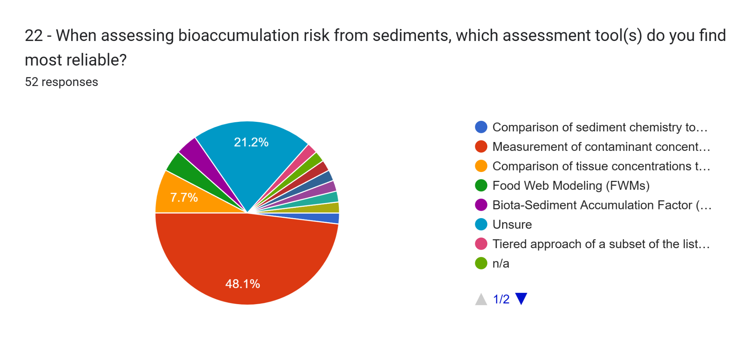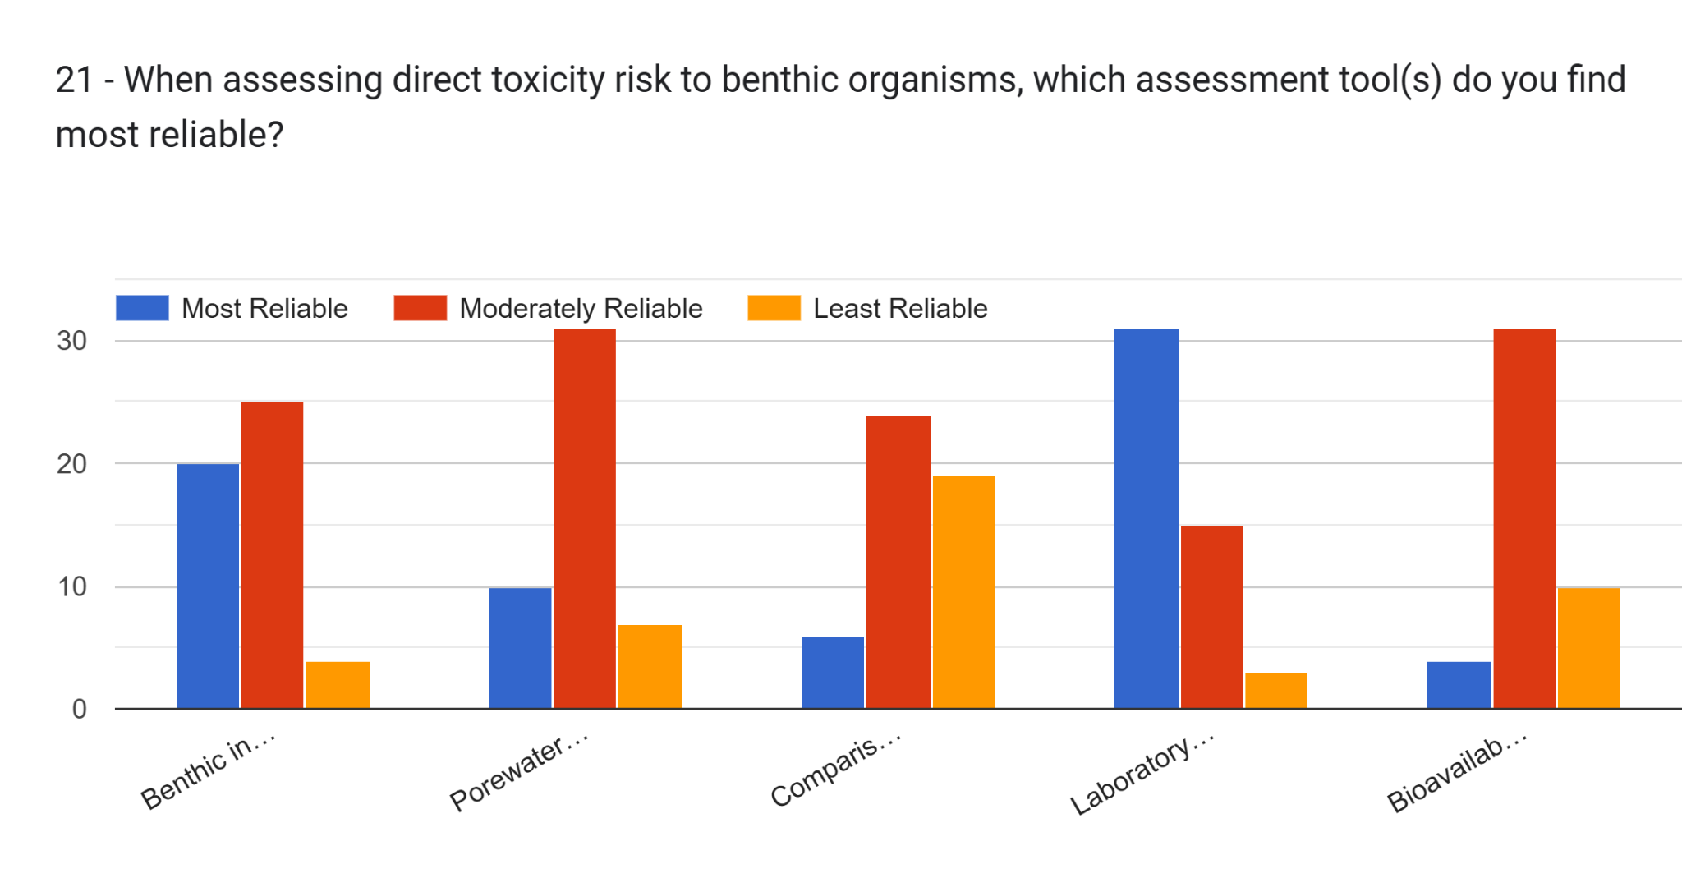



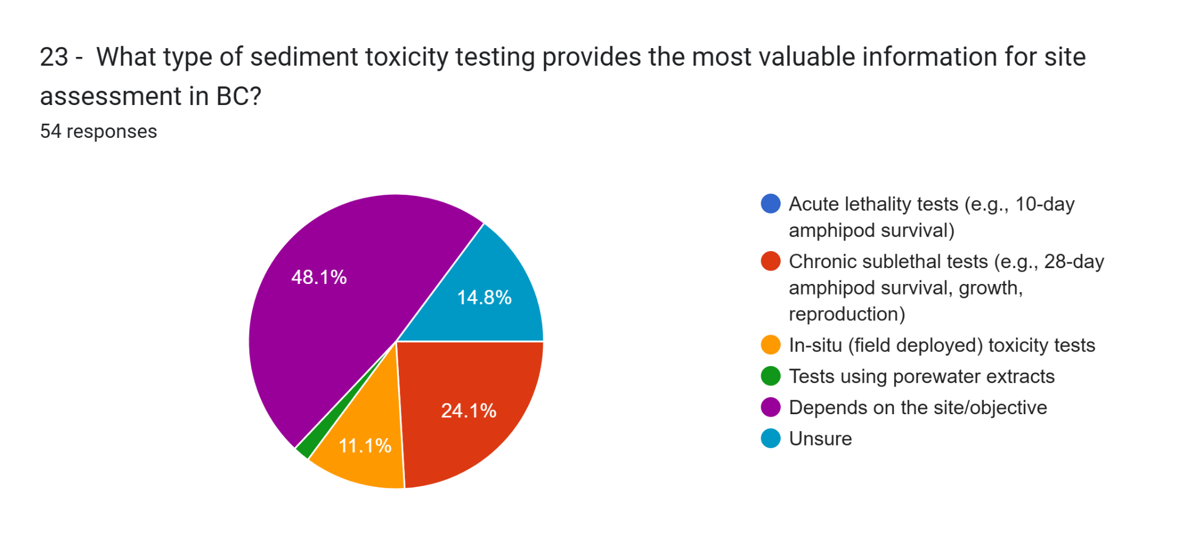

24 - How can sediment standards better account for the cumulative effects of multiple contaminants often found at sites?   37 responses

* regional/area studies would be needed
* Difficult to express in a single number/standard - conservative safety factors based on the literature may be an option
* BC's original sediment criteria attempted to do this, similar to a mechanism used and published by Don MacDonald in the late 90s and early 2000s. Mean sediment quotients. However, it can be a little difficult to do, and to interpret the resulting value.
* Great question --- it would be cool to see consideration given to Total HQs or other models.
* it cannot. Same with synergistic effects that are unknown. Save the science experiments for massive sites such as smelters, pulp mills or military bases. The CSR was intended to provide certainty for landowners after the Expo 86 lands, let's not lose sight of that.
* This is applicable to all media... Either adjusting the "allowable EC" to consider this, or in a risk assessment, reducing the acceptable HC/ILCR to consider this.
* Published guidance on contaminants with the same mechanism of action - ie/ sum quotients. For contaminants with different mechanisms of action, I'm not sure save for whole sediment toxicity testing. Maybe published known interactions?
* Integration of a framework that considers cumulative toxicity, including those constituents that have the same/similar toxic modes of actions (PAHs, TCDD/F, select metals) and those that have antagonistic modes of action (metals and ions).
* Need to be interpreted with other LOEs (toxicity tests, benthos) as part of ERA; definitely not sum of HQs (or SQs) across contaminants
* Ensure additivity must be included
* The standards should include a safety factor to account for this
* do we need to? if risk assessment likely anyways and its accounted for there through actual testing?
* Assessment methods that allow for exposure to the all the contaminants such as those based on toxicity testing are best for assessment cumulative effects.
* One option is the mean Sediment Quality Guideline quotient (mSQGq) from Puget Sound (see my response earlier)
* Proposing and formulating a chemical mixture toxicity approach for the suit of multiple contaminants at specific, local or regional sites.
* not sure
* Adopt a tiered assessment framework
* Difficult - better to conduct toxicity tests and benthic surveys which capture cumulative effects
* expand list of contaminates with developed standards (PFAS, etc.).
* I would love to see more toxicity identification evaluations when multiple contaminants are present.
* I don't think they can, and truth is it seems less important than the main toxicant that results to mortality.
* Laboratory whole-sediment toxicity testing using the media that contains the multiple contaminants/mixture which is the best approach for surface water testing to consider mixture toxicity and routinely done as part of effluent release criteria (i.e. USEPA Gold Book for effluent release has a whole sediment toxicity release criteria which is also likely going to be the upcoming/pending criteria for releasing oil sands process water in alberta/AEPA)
* Since contaminant mixtures can be highly variable, particularly in larger sites such as water lots and harbours, sediment standards as numerical values may not be appropriate for or able to account for this. Use of multiple lines of evidence where site complexity warrants is more likely to be able to assess the cumulative effects of contaminants since which the particular contaminant(s) that is/are eliciting the greatest adverse effects may not be able to be determined without something like a toxicity identification evaluation, and TIE studies are often not conclusive in proving direct causality associated with a specific contaminant.
* They won't - that is why one option is for sed standards to be a screening step (default value) - with room to look at whole sediments and site specific information after that.
* n/a
* Once the studies have been undertaken and the sites and locations are all known one can start to understand which combinations or contaminants are the worst on the specimens being studied.
* When we develop environmental quality guidelines, for chemicals within the same family or having the same mode of action, an additive model is often protective (TU, hazard index, TEFs, or something similar). This could fall within a guideline for a group or class of chemicals e.g., dioxins and furans, PCBs, or this could be a consideration within supplementary guidance on how to consider cumulative effects of a variety of chemicals at individual sites. If the latter, this could be parked until the approach to developing standards is completed.
* complex, categorize contaminations by mode of action and most potent be the threshold
* By moving away from reliance on numerous individual substance guidelines, and more toward total or subgroup thresholds that also include bioavailability adjustment as applicable. This works will for broad groups such as PAHs, PCBs, etc. For more complex mixtures that include multiple types of contaminants, validation with laboratory tests will be needed, so the standards themselves could focus more on the gradient of response rather than bright line standards.
* Include summed parameters for substances with similar mechanisms of toxicity
* No standards have achieved this in any regulated media. There are alot of factors at play in the aquatic environment including multiple sources (pw, sw, gw, sed) contributing to cumulative effects. Currently we need to update how we assess single parameters with higher levels of confidence and more robust standards before we tackle cumulative effects.
* Using sediment HI approach similar to Pel-q and mean pel-a approach.
* I dont think this is feasibile - would be assessed on a site by site basis. could provide document of potential known cumulative effects for insight, but I think developing standards would be incredibly difficult.
* Better left to risk assessment. I suppose there is a theoretical risk of several contaminants all being present at concentrations less than their respective standard and their mode of action being similar resulting in unacceptable cumulative risk but I think the conservative nature of generic standards, even using a tiered approach means that this will rarely occur.
* Derive a Cumulative Effect Index that is based on the number of substances exceeding a standard and the magnitude of the exceedances. A CEI of zero means that all analyzed substances meet the sediment standards. A CEI of 10 or more could be considered as a factor in whether the sediments make it a high risk site.
* run some controlled mixture toxicity studies to understand effects or in situ so environmentally relevant exposure scenarios are better understood
* Creation of normalized impact values or toxicity factors, use of whole-sediment tox tests

25 - From a regulatory science perspective, what are the key factors for ensuring updated sediment standards are implementable, enforceable, and achieve the desired environmental protection outcomes?   45 responses

* they cannot be too complicated that it is difficult to apply (simple to use). They should not be lower than background concentrations as this will add more work to determine local background concentrations. New standards are needed for emerging or other contaminants (expand the sediment standard list). Increased lab costs will result in fewer samples analyzed which may increase uncertainty.
* Practicality, ease of use, based on current science
* Standards should not be set below or too close to background concentrations.
* I am not sure I understand the question, but I think the updated sediment standards do need to better capture things like low-level contaminant loading to sediments from sources like CSOs and WWTPs. It would be great to see these standards as a driver for the Province of BC to be a leader in mitigating contaminant impacts from municipal discharges.
* Two overused catchphrases are applicable here: K.I.S.S. , and don't let the perfect be the enemy of the good.
* simplicity
* Clear unambiguous guidance and access to guidance
* Understanding the level of protection (as well as protection for all trophic levels) desired for site type categories and ensuring that the standards derived are clear in how those desired levels of protection are met.
* Clarify sensitive/typical sites (if a distinction is needed at all); determine spatial scale at which SedQC exceedances need to be interpreted (e.g., 1/10 station or more?) to determine if CSR standards are met or not
* Need to be realistic and non-optional
* Making them easy to understand so that they are applied correctly
* standards need to account for toxicity modifying factors (e.g. pH, organic carbon, etc..)
* different tiers of standards, site use, urban environments
* Defensible, easy to implement, enforceable
* Clear scientific basis. If decision made to be more precautionary than scientifically-derived, then the rationale/clearly should be clearly descdribed (even if it is not a scientific rationale).
* For any media sampling for environmental proposes I believe the standards should be relevant to the laboratory capabilities, cost and complexity of sampling method and adjustable for the site specific factors like land use and potential risk pathways.
* Weight of Evidence, ecosystem-based approach and One Health approach in tandem with the precautionary principle following the UN sustainable development goals (SDG), including Life Below Water (SDG 14), focusing on conserving and sustainably using the oceans, seas, and marine resources for sustainable development, aiming to protect marine life, reduce pollution, and address overfishing.
* not sure
* Provide decision trees, flowcharts, and worked examples in guidance documents. Integrate chemistry, toxicity tests, and benthic community data in a weight-of-evidence (WOE) approach
* clear direction of how and where standards apply in a protocol
* Sufficient data and sound derivation method so that standards are protective at the desired level of effect (e.g., EC20)
* na
* Educating the regulators on how the standards were derived and the limitations of those standards. As well open dialogue and communication to keep improving the standards.
* Keep it simple. Keep it practical.
* Considerate of laboratory detection limits/laboratory abilities (do not set standards at levels below laboratory detection limits)
* They can't be too complicated (i.e., requiring expensive analyses) at Tier 1. An approach that applies more detailed analyses as degree of contamination (concentration, extent, bioaccumulation potential) increases seems to be most likely to achieve reasonable environmental protection outcomes without a need to frequently default to the use of enforcement actions such as investigation and remediation orders. Clear environmental protection goals need to be clearer in policy - every site should not automatically default to "sensitive sediment use".
* -Alignment with best practice elsewhere (i.e., don't reinvent the wheel)
  + -Leverage tools/methods from elsewhere
  + -Documentation of rationale for tools/methods/derivation procedures/underlying datasets
  + -Be prepared to make the judgement/policy calls that will be necessary (this might be challenging, so plan ahead for it)
  + -Consider (not sure this is feasible) looking at lit to see where std were applied and how that aligned to predicted risks and post-remediation outcomes. Folks like Steve Bay, Allen Burton, and Tim Canfield,
* n/a
* Education and clear implementation guidelines.
* Should be based on the best available scientific methods and allow account for site-specific characteristics to be accounted for to a certain degree. Should be easy to understand and implement by the user.
* have engagement with practitioner community and industry to understand and unintended consequence
* There are so many. But one that comes to mind is the need for consistency in protection goals (especially acceptable effect sizes for lab testing and field validation tools).
* Realistic standards in terms of concentrations encountered and associated with effects with a transparent derivation, excluding substances without reliable data sets
* Honestly, the SABS vs. the CSR vs. sites requiring certification documents - all have different science perspectives and key factors at play currently
* Sediment quality management is generally a watershed (or coastline) concern except in cases with limited impacts that directly result from an activity (e.g., TBT from historic hull cleaning).
* Regular revisits to ensure aligned with best practices and consider a working group tasked to stay on top of best practices in sediment assessment.
* Input from the professional community with feedback taken into consideration. Clear expectations/guidance from ENV on implementation from the start.
* sediment assessments should be required to have a field observation / tox test if exceed a protective standard. must include a background / off-site assessment, as absence could be due to mortality tox or avoidance behaviours.. or maybe no one ever lived in the sediment!
* It's important that sites with concentrations of contaminants that are not causing impairment don't regularly get identified as contaminated and need to go through a time and money consuming risk assessment.
* They need to be easily applied, covering a similar range of substances to Schedules 3.1 and 3.2
* Sufficent toxicity data is needed that provides clear evidence that these regulations are indeed protective and how mixtures of contaminants will behave
* Simplicity of application, even if that requires that they're overly conservative. Allowing additional tiers such as risk assessment, helps address the concern associated with being overly conservative. Perhaps there could be an intermediate step before full RA. If the specific steps used to derive a given standard are clear and a practitioner can show that any of the derivation steps are not appropriate for a given site and can modify the approach with site-specific info (tox test for a more appropriate site-specific species, etc), perhaps that could be implemented as well, but simple concservative standards allow for easier implementation, enforceability... and perhaps it provides a precautionary principle component that helps protect for cumulative effects etc.
* Ensure that the laboratories can easily reach assess the media and obtain results below the standards.
* I think they need to be risk-based and scientifically defensible. I also think they need to be relatively simple to apply and geared for screening purposes.
* Easy to interpret and implement, rely on achievable laboratory limits and analyses